Dear Tribal Members,
The Nez Perce Tribe is excited to announce the expansion and optimization of our centralized Amazon Business account. We are pleased to offer this benefit free of charge to Tribal employees and Tribal members (once membership has been verified).
This new program provides access to Amazon’s extensive product selection and competitive business pricing for both personal and professional purchases.
Registration Link: https://www.surveymonkey.com/r/TribalMemberAmazon
Amazon Business offers the same user-friendly shopping experience as Amazon.com, along with additional benefits including:
- Free expedited shipping through Business Prime
- Eliminating the $139.00 annual Amazon Prime membership fee
- Business-only discounts, including the option to select an Amazon Delivery Day to reduce delivery frequency and unlock additional savings
- Business-specific pricing, including quantity/bulk discounts on eligible items
- We are also working with Amazon to highlight local businesses, diverse sellers and sustainable products!
- Access to a dedicated Amazon Business Customer Service team at 866-486-2360 or through Amazon Customer Service
All users will be vetted prior to being added to the member group within the Amazon Business account. To begin the process, please complete the request form linked below. Once your submission is reviewed and approved, you will receive an invitation link to register your Amazon Business account. After registration is completed, Tribal administration will finalize approval so you can begin shopping.
Please allow approximately 1–3 business days for the full approval and onboarding process.
Please note the following important information regarding your Amazon Business account access:

1 – While we are responsible for initially adding users to the account, we are not administrators of individual accounts. Users will be responsible for managing order issues, returns, password resets, account recovery, and other account-related matters. Our capacity to provide support is limited; however, we have included helpful screenshots and instructions below to assist you with setup and navigation.

2 – At this time, the Amazon Business membership does not include Prime Video, Amazon Music, or other consumer Prime entertainment benefits. We are currently exploring options to add these services in the future, but they are not included at this time. If you would like to retain access to those benefits, please keep your personal Amazon consumer account active.

3 – If your Tribal membership status changes, your purchasing access through the Tribal Amazon Business account will be removed. However, you will still be able to log in to your account to access order history for returns, recordkeeping, or tax purposes.

4 – Some users may qualify for tax-exempt purchasing benefits through the Amazon Business account. For example, enrolled members of an American Indian tribe may be eligible for exemption from Idaho sales tax when purchases are both made and delivered within the boundaries of an Indian reservation. In addition, individuals residing in states without a statewide sales tax may not be charged sales tax on eligible purchases.

We recommend verifying your sales tax status and eligibility before making any purchases.

If tax exemption applies to your purchase, this can be a valuable benefit. However, it is important to ensure the exemption is only used for eligible purchases. If an item or purchase does not qualify, please remove the tax-exempt status before completing your order. Users are responsible for any taxes, penalties, or related costs resulting from the incorrect use of a tax exemption.

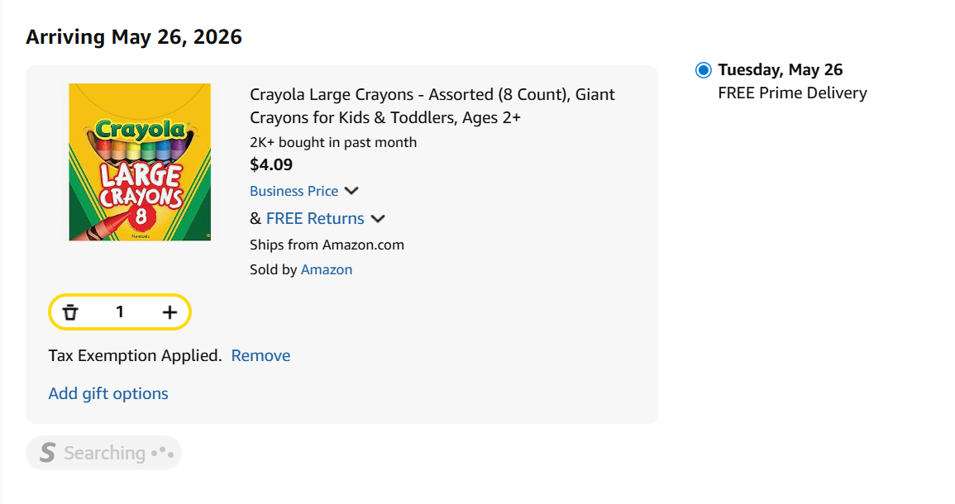
QR Code
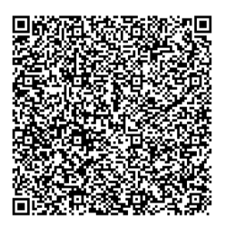
Screenshot: Tax exemption application
Thank you,

Starr Wallace
Nez Perce Tribe
Accounts Payable/Receivable Supervisor
208.843.7317

