Exhibit 7 Photos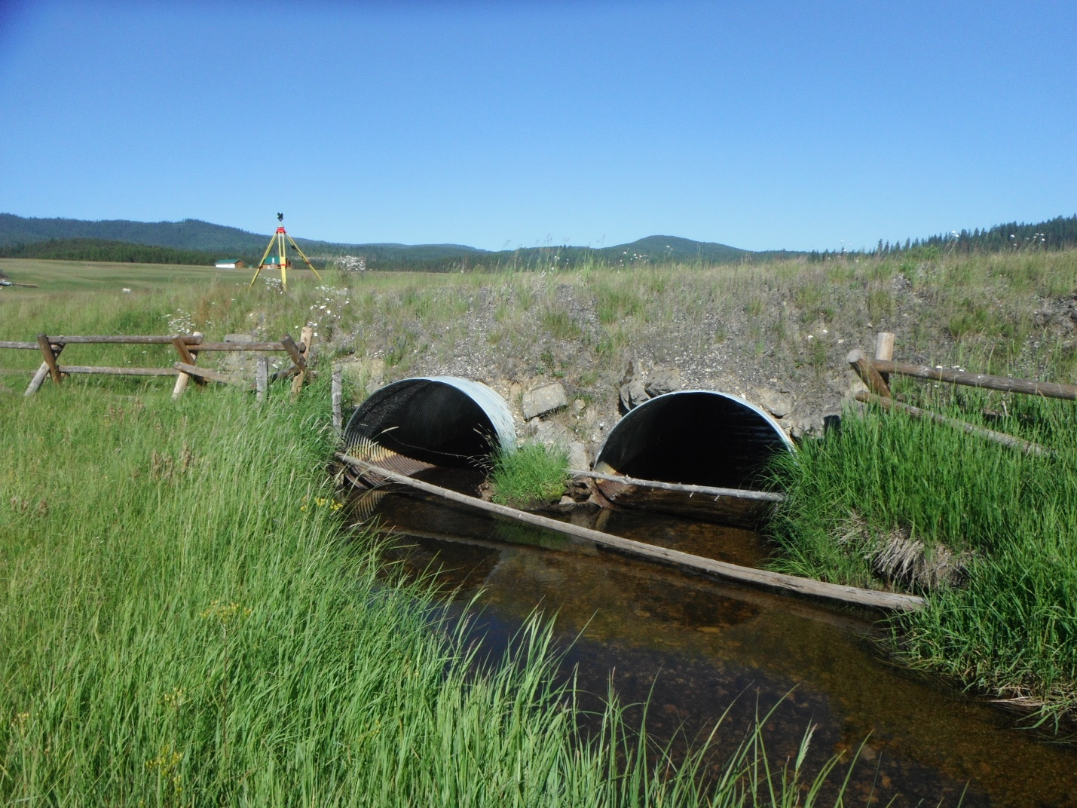

Big Elk Creek looking downstream

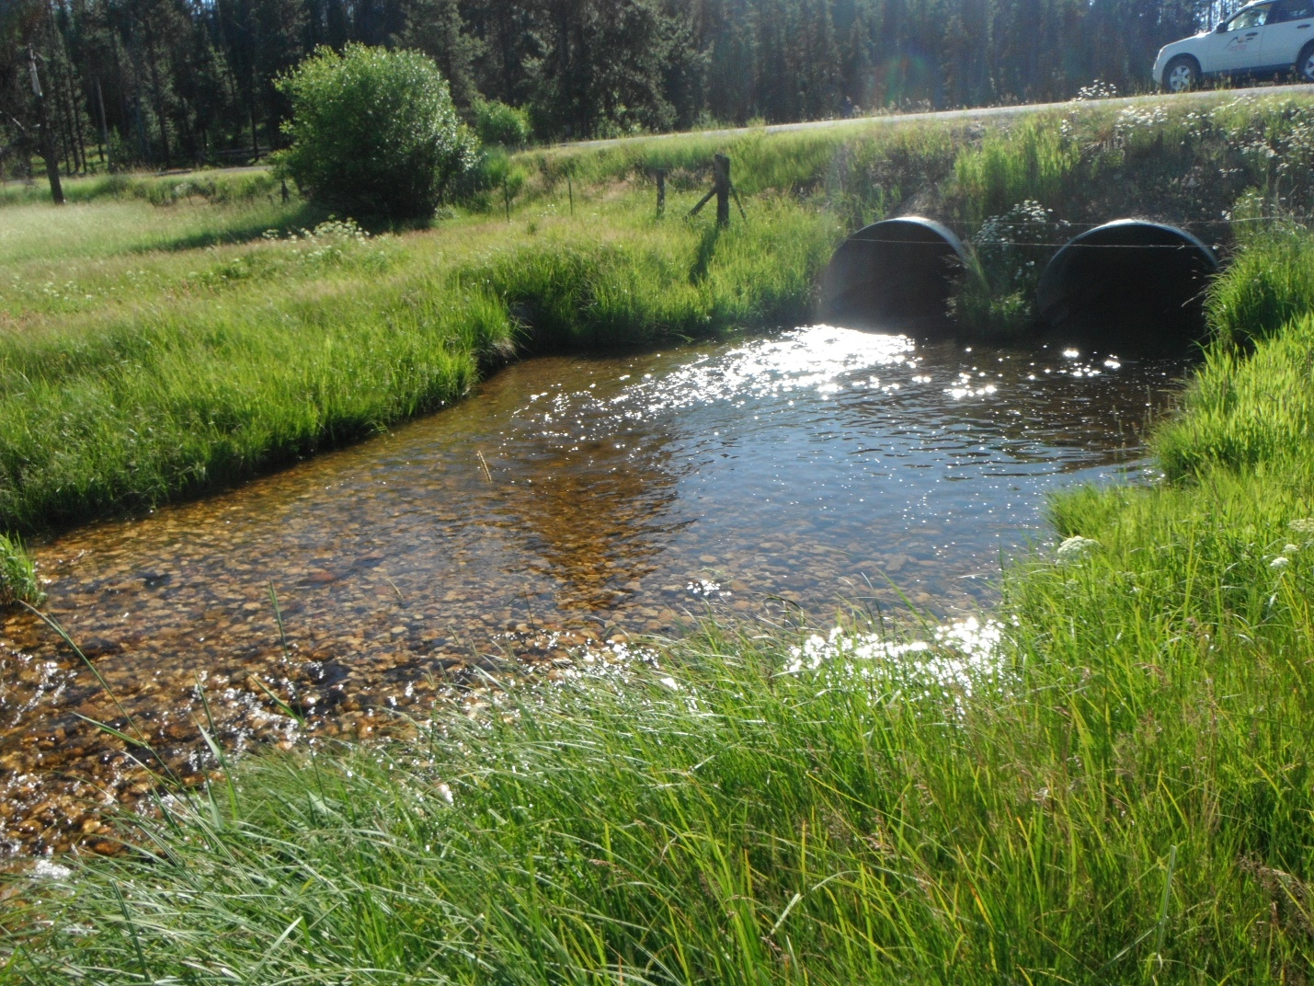

Big Elk Creek looking upstream

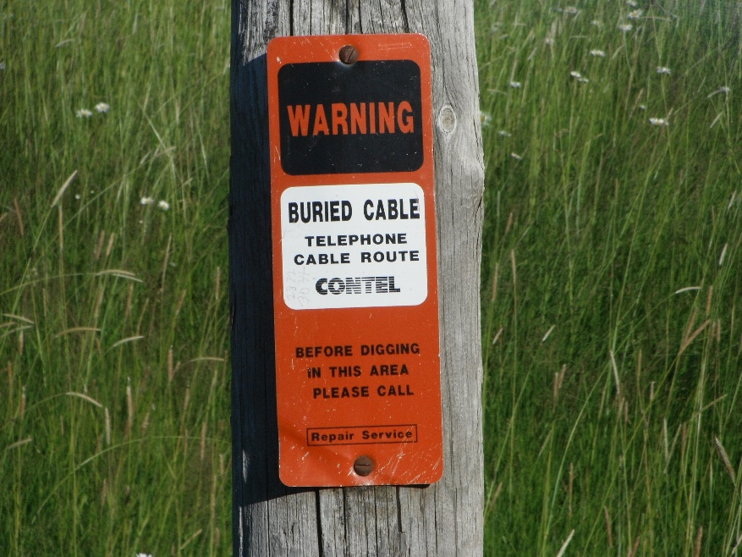

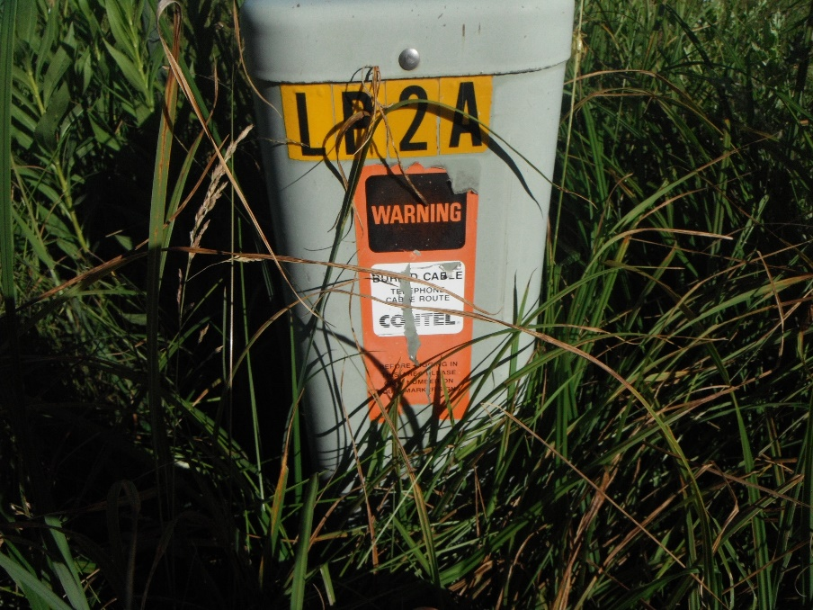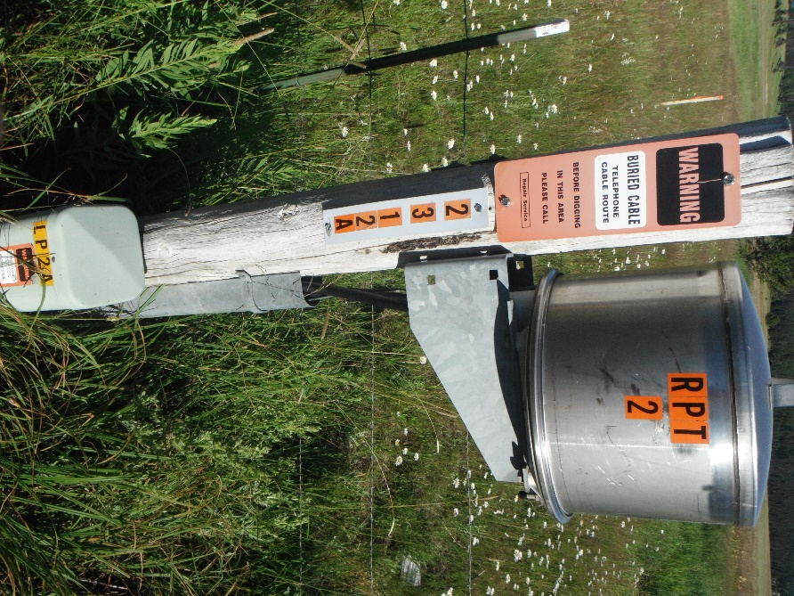

Cable, power and telephone boxes in the project area. Others may exist in the area, and it is the responsibility of the contractor to ensure all buried lines are addressed. 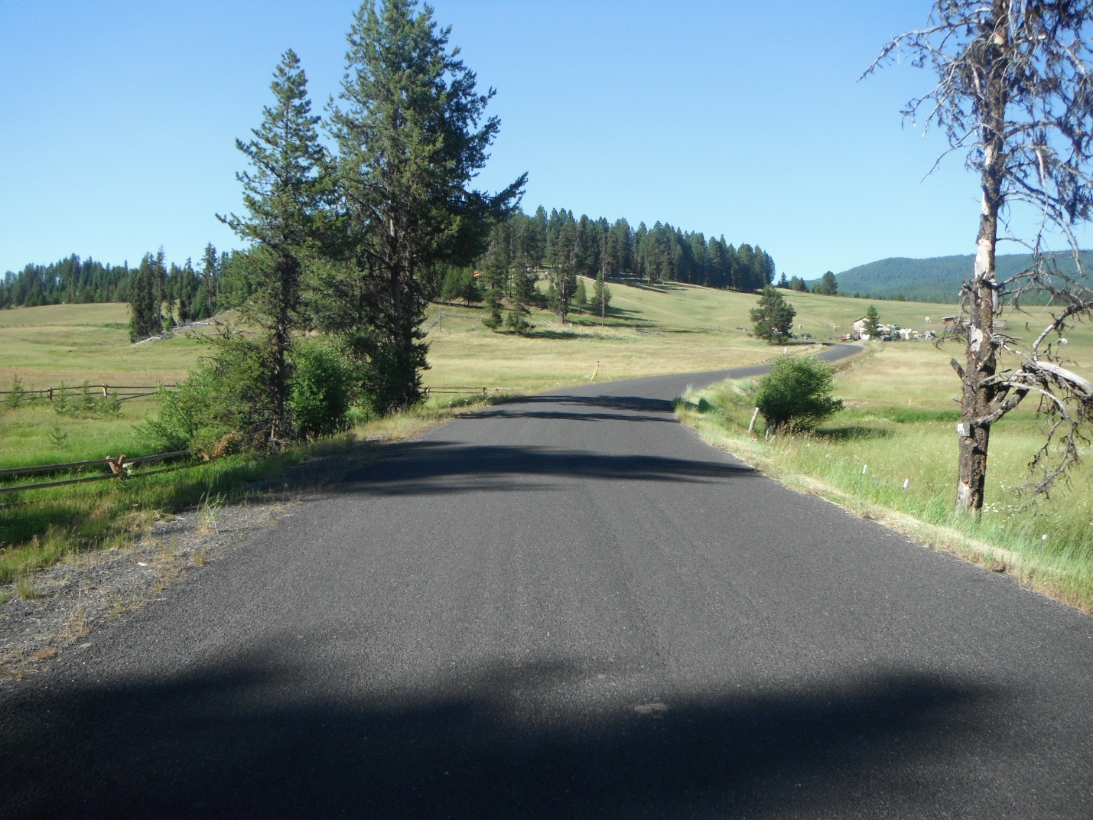

Road surface at Big Elk Crossing looking north.

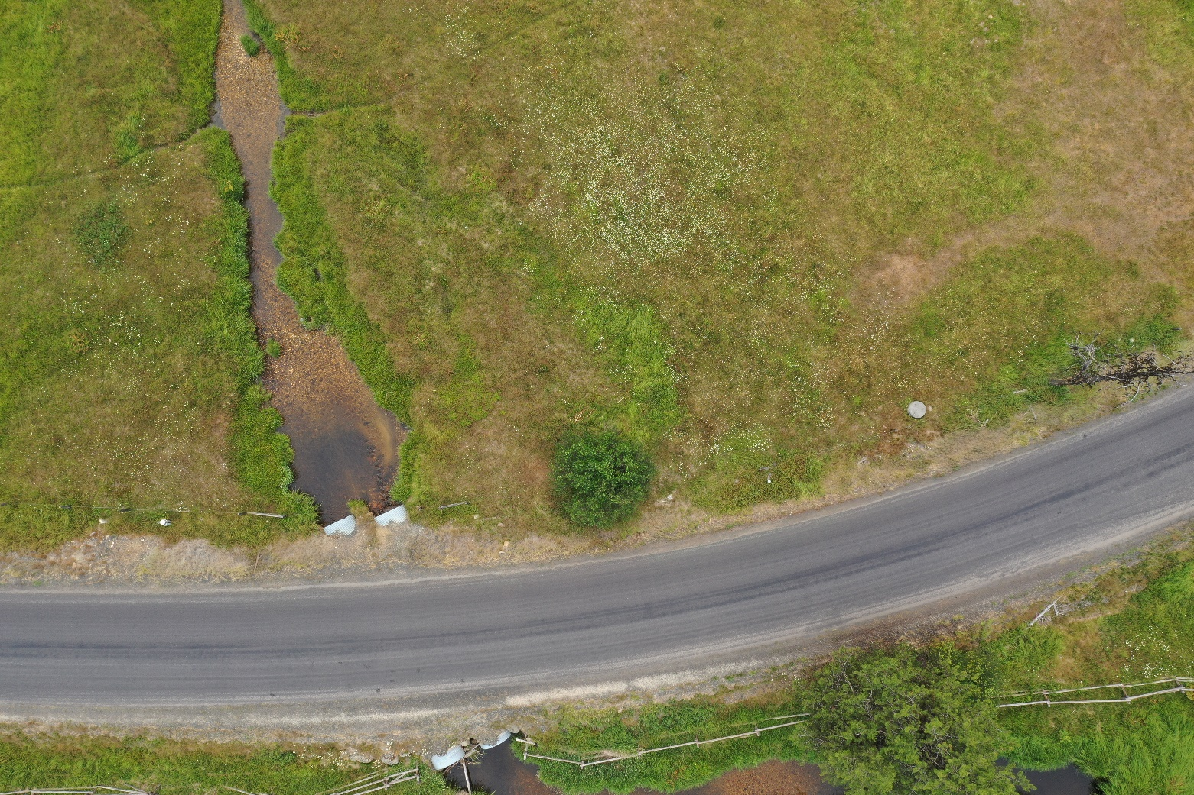

Aerial image of Big Elk Creek culvert.