Sally Ann Creek Watershed Crossings AOP Design Package

Bid Process Overview: The Nez Perce TRIBE is accepting bids for the project titled Sally Ann Creek Watershed Crossings Aquatic Organism Passage (AOP) Design Package, which is described below. Bids must be emailed to mirandag@nezperce.org or mailed to the locations found in Section A. The bidding process is from June 21st to July 20th; any bids received after 3:30 P.M. on the closing date will not be considered. Award of the contract is contingent upon funding, and any combination of the proposed sites may be awarded based upon funding and ability to meet the contract deadlines.

General: The intent of this project is to survey and design replacement structures for up to four existing road crossing structures in the Sally Ann Creek watershed near Clearwater, Idaho (See Figure 1 and Exhibit 3). The existing culvert structures are undersized and impede fish passage at various flows while contributing sediment to the stream. The bridge is a source of sediment and a failure risk, reducing the instream fish quality of the stream and watershed. The purpose of the project is to improve habitat conditions and to provide fish passage for steelhead and resident fish at all life histories.

SECTION A—OFFER FORM

OFFER FORM |  | 1. SOLICITATION NO.  Culvert/Bridge Designs |  |  | 2. TYPE OF SOLICITATION  Request For Proposals |  | 3. DATE DUE  7/20/2022 | PAGE OF PAGES  1 of 36 pages
IMPORTANT - The “offer” section on the reverse must be fully completed by offeror.
4. MAIL OFFER TO |  |  |  | 5. ADDRESS OFFER TO
Nez Perce TRIBE  DFRM Watershed Division Office  Attn: Miranda Gordon  P.O. Box 365  Lapwai, Idaho 83540 |  |  |  | Delivered to:  DFRM Watershed Division Office  28764 Salmon Lane  Lapwai, Idaho 83540
6. FOR INFORMATION  CALL: | A. NAME  Miranda Gordon |  |  |  |  | B. TELEPHONE NO. (Include area code)  208-621-3547
SOLICITATION
NOTE: In RFP solicitations “offer” and “offeror” mean “bid” and “bidder.”
7. THE NEZ PERCE TRIBE REQUIRES PERFORMANCE OF THE WORK DESCRIBED IN THESE DOCUMENTS (Title., date):

Sally Ann Creek Watershed AOP Crossings Design Package
Nez Perce TRIBE, DFRM Watershed
IDAHO COUNTY, IDAHO

FAXED OFFERS ARE NOT ACCEPTABLE. OFFERS MUST BE RECEIVED BY July 20, 2022 AT 3:30 PM LOCAL TIME.

8. The Contract time shall begin on receipt of notice to proceed and the work shall be completed no later than January20, 2023. This performance period is mandatory.
9. ADDITIONAL SOLICITATION REQUIREMENTS:
A. Proposals to perform the work required are due at the place specified in Item 4 by 3:30 PM local time. Envelopes containing offers shall be marked to show the offeror’s name and address. If hand delivering proposals, please deliver to the physical address listed above. If sending by mail, please address to the PO Box listed above.

REQUEST FOR PROPOSALS (“RFP”) FOR CONTRACTOR SERVICES FOR THE NEZ PERCE TRIBE FISHERIES WATERSHED DIVISION

SERVICES AND PRICES

Sally Ann Creek Culvert #1
Item | Description | Quantity | Unit | Total Price
1 | Site Review and Investigation | 1 | Lump Sum | $
2 | Meetings, Coordination, and Project Management | 1 | Lump Sum | $
3 | 15% design Review | 1 | Lump Sum | $
4 | 30% Design Review | 1 | Lump Sum | $
5 | 80% Design Review | 1 | Lump Sum | $
6 | Final Designs, Cost Estimate, and Basis of Design Report | 1 | Lump Sum | $
TOTAL PRICE |  |  |  | $

Sally Ann Creek Culvert #2
Item | Description | Quantity | Unit | Total Price
1 | Site Review and Investigation | 1 | Lump Sum | $
2 | Meetings, Coordination, and Project Management | 1 | Lump Sum | $
3 | 15% design Review | 1 | Lump Sum | $
4 | 30% Design Review | 1 | Lump Sum | $
5 | 80% Design Review | 1 | Lump Sum | $
6 | Final Designs, Cost Estimate, and Basis of Design Report | 1 | Lump Sum | $
TOTAL PRICE |  |  |  | $

Sally Ann Creek Culvert #3
Item | Description | Quantity | Unit | Total Price
1 | Site Review and Investigation | 1 | Lump Sum | $
2 | Meetings, Coordination, and Project Management | 1 | Lump Sum | $
3 | 15 % design Review | 1 | Lump Sum | $
4 | 30% Design Review | 1 | Lump Sum | $
5 | 80% Design Review | 1 | Lump Sum | $
6 | Final Designs, Cost Estimate, and Basis of Design Report | 1 | Lump Sum | $
TOTAL PRICE |  |  |  | $

Wall Creek Bridge
Item | Description | Quantity | Unit | Total Price
1 | Site Review and Investigation | 1 | Lump Sum | $
2 | Meetings, Coordination, and Project Management | 1 | Lump Sum | $
3 | 15 % design Review | 1 | Lump Sum | $
4 | 30% Design Review | 1 | Lump Sum | $
5 | 80% Design Review | 1 | Lump Sum | $
6 | Final Designs, Cost Estimate, and Basis of Design Report | 1 | Lump Sum | $
TOTAL PRICE |  |  |  | $
DESIGN PACKAGE TOTAL |  |  |  | $
BASIS OF AWARD- Technical proposals are required to be submitted with your offer. See Section 8 for instructions and evaluation/award information.
CRITICAL DATES- See Section 6.1.8 for project schedule.

- PURPOSE OF RFP

The Nez Perce Tribe Fisheries Watershed Division (NPT), is soliciting proposals from selected qualified engineering firms ("Offerors") to provide contract services ("Services") for the Sally Ann Creek Watershed Crossings Aquatic Organism Passage Design Project. Services include designs, cost estimates, specifications, Basis of Design Reports, and bid documents to fund up to four projects seeking to address partial fish passage barrier culverts and sediment sources from these crossings.

The project sponsor seeks to produce designs for partial fish passage barriers for the Sally Ann Creek culvert crossings and Wall Creek Bridge so that they will pass all life stages of ESA listed steelhead and other native aquatic species while improving the aquatic habitat by reducing sediment loading into the stream.

- BACKGROUND

There are four proposed project sites contained within this Request For Proposals: two culvert crossings on Sally Ann Creek and Sally Ann Creek Road, one crossing on Sally Ann Creek/ Sill Creek and Wall Creek Road, and one bridge crossing on Wall Creek and Wall Creek Road near Harpster and Clearwater, Idaho (Figure 1 below and site photos in Exhibit 3). All four structures are owned and managed by Idaho County Roads Department. Project partners share a long-term vision involving the restoration of fisheries habitat where it can be beneficial to ESA listed steelhead and other native resident species. Agriculture (including grazing), logging, and the transportation system have increased sediment and water temperatures, decreased riparian condition, and caused major changes in channel form and function within the Sally Ann Creek watershed and subsequently the South Fork Clearwater watershed. Project designs would seek to restore passage and improve habitat conditions at and near the road crossings.

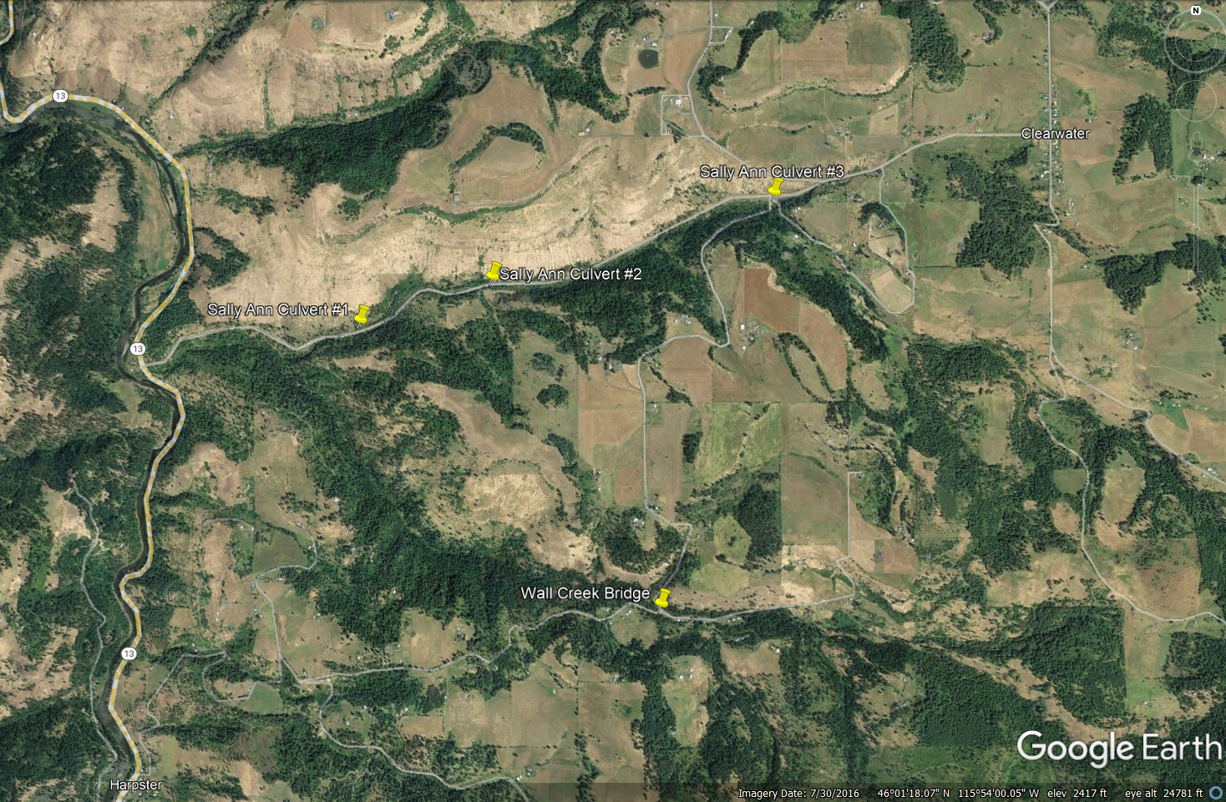
Figure 1. Project site locations.

The Sally Ann Creek culvert #1 is the first crossing in Sally Ann Creek managed by Idaho County upstream of Highway 13 and the confluence with the South Fork Clearwater River. The 72" circular culvert plugged and failed in 2018, washing out the Sally Ann Cr Road and was subsequently replaced with the same culvert specifications due to funding limitations. In 2019, the culvert plugged again and damaged the inlet of the culvert, sending debris and water down the road and ditch; the culvert did not completely fail but is not functioning at full capacity. Currently, the stream is eroding the material under the culvert inlet due to the poor alignment of the crossing with the stream channel, there is a significant outlet drop, the culvert is undersized to pass high water events with the crushed inlet further limiting its capacity to pass water and material, and the circular pipe may be too long and steep to pass fish without native bed material and habitat diversity within the crossing.

The Sally Ann Creek culvert #2 is the second County managed crossing on Sally Ann Creek. It is a 72" circular culvert that has been severely damaged; during the high water in 2019, an approximate six-foot extension was lost from the end of the pipe along with a significant portion of the road fill and shoulder surrounding the outlet. The culvert is rusted through with pin holes throughout the entire length, is undersized, and contains no substrate inside the pipe.

The Sally Ann Creek culvert #3 is the third County managed crossing on Sally Ann Creek and is located immediately at the confluence of Sally Ann Creek and Sill Creek on Wall Creek Road. The undersized 60" circular culvert has been crushed by the settling roadway with a break midway in the pipe. Holes rusted through exist through the entirety of the structure with a tree growing through the middle of the pipe near the outlet. Water flows both through and under the culvert. A scour pool has developed below the outlet drop, changing the stream channel shape downstream. The potential for a bridge in replacement may exist dependent upon hydrologic analyses, cost estimates, and County approval.

Wall Creek joins Sally Ann Creek roughly a mile upstream of the confluence with the South Fork Clearwater River. The bridge is located on Wall Creek Rd near the intersection with Shira Rd. It is undersized with a 10.3' span, serving as a pinch point in the stream channel. More importantly, however, the structure is beginning to fail; the stream is undercutting the concrete footings, a concrete slab wingwall has fallen in the stream channel, and the steel decking material retaining road gravel on the road surface has large holes that allow materials and sediment to fall directly into the stream. The cross drain at the intersection of the two roads does not appear to be functioning properly; with the outslope of the road surface, the road surface runoff appears to drain toward the stream. Additionally, there is a ford crossing created by 4wheelers immediately below the bridge; not only do the vehicle tread of the ford bring along road gravel and sediment to the stream but the tread also funnels runoff and sediment from the road into Wall Creek. Sediment delivery is a primary concern at this site.

The crossing replacements will increase the hydrologic capacity of the crossings and reduce the chances of failure in the future, prevent excess sediment from entering the Sally Ann Creek drainage into the South Fork Clearwater River and negatively impacting all life stages of aquatic species including juvenile Spring Chinook and steelhead. The new structures will pass all aquatic organisms, including all life stages of anadromous and resident fish. These replacements will be designed in partnership with Idaho County and the replacements in the near future and will allow improved access to approximately 2.6 miles of stream.

- SCOPE OF SERVICES
  - The following Scope of Services shall be the basis for Qualification response by Offeror under
this RFP. At the discretion of the NPT certain additional services may be assigned to Contractor during the course of the Services. Any combination of the proposed sites may be awarded based upon funding and the ability to meet the contract deadlines.

Sally Ann Creek Culvert #1 AOP, (Sally Ann Creek Road, T 31 N, R 4 E Section 22 SE1/4 NW1/4, 46.012036N, -115.945378W)
- Stream simulation and fish passage required.
- Minimal hardened materials for natural stream simulation required.
- Potential channel realignment.
- Summer work window will apply for implementation.
- A Stream Diversion/Erosion Control plan will be required.
- Landowner access agreement will be required.

Sally Ann Creek Culvert #2 AOP, (Sally Ann Creek Road, T 31 N, R 4 E Section 22 SE1/4 NE1/4, 46.014565N, -115.93501 W)
- Stream simulation and fish passage required.
- Minimal hardened materials for natural stream simulation required.
- Potential channel realignment.
- Summer work window will apply for implementation.
- A Stream Diversion/Erosion Control plan will be required.
- Landowner access agreement will be required.

Sally Ann Creek Culvert #3 AOP, (Sally Ann Creek Road, T 31 N, R 4 E Section 23 NE1/4 NE1/4, 46.018581N, -115.912658W)
- Stream simulation and fish passage required.
- Minimal hardened materials for natural stream simulation required.
- Summer work window will apply for implementation.
- A modular bridge may be a cost effective alternative dependent upon analyses.
- A Stream Diversion/Erosion Control plan will be required.
- Landowner access agreement will be required.

Wall Creek Bridge, (Wall Creek Road, T 31 N, R 4 E Section 26 NE1/4 SW1/4, 45.996528N, -115.921556W)
- Stream simulation and fish passage required.
- Minimal hardened materials for natural stream simulation required.
- Roadway cross slope, profile, and cross drains may need adjusted depending upon hydraulic analyses.
- Reduction of sediment sources into Wall Creek.
- Summer work window will apply for implementation.
- A Stream Diversion/Erosion Control plan will be required.
- Landowner access agreement will be required.

Specifications:
Road Design: The existing roadway alignment shall be maintained with only minor adjustments to accommodate the new stream crossing structures. BMP improvements shall be incorporated to reduce the risk that sediment from road will reach the stream. The projects are not intended to improve speeds or promote additional traffic capacity and thus roadway design shall concentrate on preserving and protecting the facility and improving BMP’s. This philosophy is the basis for the “Guidelines for Geometric Design of Very Low-Volume Local Roads” (VLVLR) shall be the design specification for this project. Other design references and specifications are:
- AASHTO’s, A Policy on Geometric Design of Highways and Street.
- AASHTO’s, Roadside Design Guide.
- Water Quality Best Management Practices.

Bridge and Other Drainage Structures Design: Bridges and other drainage structures shall be designed in accordance with AASHTO’s LRFD Bridge Design Specifications, latest edition.

Construction Specifications: Construction specifications shall be Standard Specifications for Construction of Roads and Bridges on Federal Highway Projects, FP-03. Drawings and specifications shall be in English units.

Design Criteria:

Road Design
- Roadway width: Match existing conditions.
- Generally maintain existing vertical and horizontal alignment.
- Roadway Crown/Inslope: match existing.

Drainage Structures Design
- Design Loadings: Per AASHTO.
- Aquatic Organism Passage and Hydraulics: All structures, bridges, bottomless arches and culverts, shall be designed to pass the 100-year flood event with adequate freeboard for debris passage. Hydraulic analysis shall be completed using a one dimensional, steady flow, water surface profile analysis and as a minimum shall model the Q₂, Q₁₀, and Q₁₀₀ flow volumes. The analysis shall include a comparison of the natural stream without any impacts of the existing crossing and proposed alternatives for the various flood events. Aquatic organism passage is also required. Stream velocities, depths, bedload transport, and hydraulic energy grade lines at the various flow volumes are of significant importance to maintaining natural stream features necessary for aquatic organism passage. The hydraulic analysis of all proposed alternatives must be comparable/compatible to the natural stream models.
- Structure Economics: Economical cost to the TRIBE shall be considered for all proposed alternatives but must meet the other criteria stated above. Low initial cost plus long-term maintenance shall be considered.
- Designs must be in accordance with HIP 4 guidelines and standards, the Endangered Species Act Section 7(a)(2) Biological Opinion and Magnuson-Stevens Fishery Conservation and Management Act Essential Fish Habitat Response: Fish and Wildlife Habitat Improvement Program (HIP 4) in Oregon, Washing and Idaho. The HIP 4 can be found at https://repository.library.noaa.gov/view/noaa/24206/noaa_24206_DS1.pdf? or made available upon request.

Surveys and Preliminary Design shall include:

- The survey and design shall include hydraulic analysis and development of alternatives and preliminary construction quantities and cost estimates for each individual site.
- The Contractor shall prepare to meet with TRIBE, County, and potential project partners representatives to discuss the alternatives, merits, risks, estimated construction costs and issues. Preliminary design alternative drawings shall be presented illustrating roadway, stream and structure geometry and horizontal and vertical alignment, and summary of hydraulic analysis. The ultimate objective of the review meeting is to answer all questions and for the TRIBE and County to provide direction to the Contractor for final design.
- After the review meeting, the TRIBE shall prepare a memo documenting the meeting discussion and any decisions and direction given to the Contractor for final design.

Final Design
Final design shall include calculations, final drawings, and special project specifications. Final design drawings shall be prepared in AutoCAD Release 2007 or later and utilize the Nez Perce Tribe Logo. Contractor shall prepare all special project specifications. The specifications shall be prepared in electronic format using Microsoft Word word-processing software. A 15%, 30% and 80% submittal will be required. The 30% and 80% submittal shall require in person or virtual meeting with the 30% being plan in hand for each site.

Conceptual Project Review (typically 15%): The Project Sponsor will notify BPA at 15% or project concept stage and help the BPA EC Lead coordinate a site visit to review project concepts, goals, and objectives and confirm the direction and planning for subsequent phases of project design. Staff biologists from the NMFS and USFWS shall be invited to the site visit. A typical site visit will include the review of limiting factors and any pertinent studies or reports that document restoration targets for implementation and draft project concepts. Additional data that may be presented and reviewed include other data sources (e.g., high resolution aerial photography, topographic maps, soil maps, GIS/CAD data layers, or other resource data). After the site visit, BPA EC Lead will collate and provide comments from BPA Technical Lead and interagency partners. Once comments are resolved, the BPA EC Lead will notify the Sponsor to proceed with the next design iteration.

Initial Review of Plans and BDR (typically 30%): Preliminary drawings, specifications, a draft Basis of Design Report, and other supporting documentation (profiles, details, cross sections, quantities, technical analyses/appendixes, etc.) for the preferred project alternative will be submitted for review. The 30% design should demonstrate incorporation of technical comments and recommendations from the previous review and shall address the design requirements outlined in Section 2.5 of the HIP 4. A BDR template addressing the HIP requirements is attached as Exhibit 2. In addition to BPA technical and functional reviews, a NMFS Engineering review may be required (see Section 2.6 of the HIP 4). The BPA EC Lead will collate comments from reviewers and interagency partners, and submit them to the Sponsor. The BPA EC Lead will notify the Sponsor to proceed to the 80% design plans once 30% comments are resolved.

Final Project Review (typically 80%): The 80% project drawings will be submitted to the BPA EC Lead. Technical, functional, and interagency reviews will take place. The 80% design should demonstrate complete incorporation of technical comments and recommendations developed at the previous design review. The 80% design submittals should include near-final drawings and specifications, including specific site locations, site plans, profiles, cross sections, details, construction quantities, implementation resource plans, and design technical analyses as summarized in a Basis of Design Report. If HIP requirements are not met, additional review iterations may be necessary. Once the BPA EC Lead and BPA Technical Lead have approved the final design, the BPA EC Lead will proceed with final agency approval and notifications.

The TRIBE and County review of the design work at the various submittals shall be for overall conformance with the project scope of work, design criteria, and generally accepted practices of design and drawing preparation. Contractor is responsible for the quality and accuracy of their work.

The Contractor shall provide the following deliverables during this Contract:
- 2 sets of 30% and 80% design package.
- 2 hardcopy and 1 electronic sets of design calculations and hydrologic analysis including BDR Report.
- 2 hardcopy and 1 electronic sets of final construction documents.
- 1 electronic copy of the (georeferenced/projected) stakeout points adequate for construction staking (.DWG or .GDB)

Agreements:
Landowner Agreements: The Contractor will obtain written permission from neighboring landowners to make staging and replacement of the structures possible through cooperative landowner agreements. A template may be available upon request.

AWARD STATEMENT
Award will be made to that offeror (1) whose proposal is technically acceptable and (2) whose technical/cost relationship is the most advantageous to the Nez Perce TRIBE. The Nez Perce TRIBE reserves the right to make cost/technical trade-offs that are in the best interest and to the advantage of the TRIBE. Award of contract is contingent upon funding.

Award may be made without further negotiations. Proposals should be submitted initially on the most favorable terms, from a price and technical standpoint, which the offeror can submit to the Nez Perce TRIBE. However, the TRIBE may, after evaluation of proposals, conduct further oral or written discussions as appropriate, with all offerors whose proposals are within a competitive range.

- INFORMATION CONCERNING RFP AND PROJECT

5.1 All correspondence pertaining to this RFP, including submittal of proposals, should be directed to:
Miranda Gordon
Nez Perce Tribe
Department of Fisheries Resources Management – Watershed Division
(208) 621-3547
Mirandag@nezperce.org

5.2 Offerors are cautioned not to make any assumptions as to the implied meaning or intent of any part of the RFP. Offerors should request clarification or additional information concerning the RFP in writing as soon as possible. ANY CORRECTIONS OR CLARIFICATIONS MADE IN ANY MANNER OTHER THAN BY A WRITTEN ADDENDUM WILL NOT BE BINDING ON NPT, AND OFFERORS SHALL NOT RELY THEREON.

5.3 Any prospective Offeror who contends that the terms and conditions of this RFP, the Contract or any aspect of the selection process (1) will encourage favoritism in the award of the Contract for Services; (2) will substantially diminish competition; (3) will violate any other statute, regulation, or law of any kind; or (4) is ambiguous, insufficient, or unfair for any reason, must file a written protest to this RFP. Failure to deliver a written protest to the address provided in “Address Offer To” box in the cover page of this RFP by the time specified in Section 6.1.2 of this RFP will be deemed a waiver of any claim by an Offeror that the selection process violates any of the items (1)-(4) of the foregoing sentence.

5.4 NPT reserves the right to (1) reject any or all proposals or (2) cancel the RFP if doing either would be in the public interest as determined by NPT.

- SCHEDULE OF EVENTS

  - The following schedule of events shall be followed for this RFP unless otherwise modified
By NPT:

    - Inquiries for clarification or additional information as described in Section 5.2,
any, must be received by NPT no later than 12:30 P.M. on the date specified in the table in Section 6.1.8.

    - Protests of the RFP, the Contract or any aspect of the selection process as set forth
in Section 5.3 must be received by NPT no later than 12:30 P.M. on the date that is three (3) calendar days before the due date for proposals.

    - Proposals must be received by NPT no later than 3:30 P.M. on the date specified in
the table in Section 6.1.8. Proposals submitted after this time will be rejected.

    - The Qualification Based Selection (QBS) process defined in Section 10.6 will be
Used to select the Contractor, if any.

    - A Contractor will be selected, if at all, no later than the date specified in the table in
Section 6.1.8. However, Contractors will not be notified until the Nez Perce Tribal Executive Committee approves the decision. This could take up to five weeks from the time of selection. The unsuccessful Offerors will be notified once the final selection has been approved.

    - Any protests of the selection decision must be received no later than 12:30 P.M. on
the date that is seven (7) calendar days after the NPT issues the selection notice.

    - The NPT intends to enter into a Contract with the selected Contractor within 45
calendar days after the due date for proposals, unless NPT, in its sole discretion, elects to extend the deadline.

    - Tentative Table of Timelines

The project schedule is as follows:
- RFP announcement June 21, 2022
- Clarification requests due by July 13, 2022
- Bids due July 20, 2022 at 3:30 P.M.
- Anticipated Notice to Proceed– August 30, 2022
- Prework meeting - TBD
- 15% submittal - September 30, 2022
- 30% submittal - October 27, 2022
- 80% submittal - December 15, 2022
- Final submittal - January 15, 2023

- NO REIMBURSEMENT FOR PROPOSAL

Offerors responding to this RFP do so solely at their own expense. Under no circumstances whatsoever will NPT be responsible or reimburse Offerors for any costs incurred in the preparation and presentation of their proposals, negotiation of the Contract and cost proposal by the Offeror, or for any related expenses or consequential damages of any kind.

- CONTENT OF PROPOSALS
8.1 Identify any confidential information that the Offeror contends is exempt from disclosure. NPT will endeavor in good faith to honor appropriate requests for exemption from disclosure, but NPT reserves exclusive discretion to determine whether information qualifies for a statutory exemption. NPT's obligation under this Section 8 shall survive selection of the Contractor.

8.2 Identify the Offeror’s experience, capabilities, and technical competence. Transportation engineering and fish passage experience are required.

8.3 Describe the Offeror’s proposed approach (work plan and methodology) for providing the Services, including a description of tasks that will be performed by each member of the project team. The proposal should address how the Offeror would implement the Services.

8.4 Identify the Offeror’s resources committed to perform the work and the proportion of the time that the Offeror’s staff would spend on the project, including time for specialized services, within the applicable time limits.

8.5 Provide the Offeror’s record of past performance, including but not limited to price and cost data from previous projects, quality of work, ability to meet schedules, cost control, and contract administration.

8.6 Provide the Offeror’s ownership status and employment practices regarding minority, women, and emerging small businesses or historically underutilized businesses.

8.7 Provide the Offeror’s availability to the project locale.

8.8 Provide the Offeror’s familiarity with the project locale.

8.9 Provide the Offeror’s proposed project management techniques.

8.10 Include a proposed schedule for performing the Services and identify any constraints that could affect the Offeror’s ability to perform the Services promptly and efficiently. The initial schedule expectation is receipt of 15% drawings and final drawings by the dates specified in the table in Section 6.1.8.

8.11 If the Offeror believes there are additional services not identified in this RFP that are necessary for successful completion of the Project, include a description of the additional services recommended by the Offeror, describe how the additional services would benefit NPT and Company, and describe the Offeror’s ability to provide the additional services.

- CONTRACT
9.1 The Offeror, if any, selected by NPT will be required to enter into a written contract in the form attached as Exhibit 1 to this RFP.

9.2 The proposal should indicate acceptance of the Contract provisions but may – in addition to and not in lieu of NPT's Contract – suggest reasonable alternatives that do not substantially impair NPT's rights under the Contract. Silence shall be deemed acceptance of the standard form of Contract.

  - If inclusion of any of NPT’s proposed contract provisions will result in higher costs for the services, such costs must be specifically identified in the proposal by the Offeror during cost negotiations and prior to selection of the Offeror as the Contractor.

- EVALUATION OF PROPOSALS

10.1 Certified Indian Owned Business (CIB): Certified Indian Owned businesses registered with the Nez Perce Tribe will be given preference. Please note if you are a registered CIB with the Nez Perce Tribe.

10.2 Proposals that do not adhere to all terms and conditions of this RFP or that are otherwise non-responsive may, in the sole discretion of NPT, be rejected or given a lower rating in the evaluation process.

10.3 NPT reserves the right to reject any and all proposals or to waive irregularities or deficiencies in a proposal if NPT determines that such waiver is in the best interests of NPT.

10.4 If two or more Offerors are equally qualified, and one of the offerors is a CIB, NPT will give preference to a Certified Indian Owned Business.

10.5 If NPT and the highest ranked Offeror are unable for any reason to negotiate a contract at a compensation level that is reasonable and fair to NPT, NPT shall, either orally or in writing, formally terminate negotiations with the highest ranked Offeror. NPT may then negotiate with the next most qualified Offeror. The negotiation process may continue in this manner through successive Offerors until an agreement is reached or NPT terminates the Contractor contracting process.

10.6 Proposal selection will be completed by a review team. The following selection criteria, listed in a descending order or importance, will be used to evaluate the content of the written proposals:

EVALUATION FACTORS

Technical Evaluation Factors: The technical proposals will be evaluated on the basis of the following factors, which are approximately equal in importance:

- Licsenced Engineer in State of Idaho.
- Past Performance.
- Proposed Schedule.
- Experience in Similar Work.
- Cost of Project.
- Understanding of the Project Goals.
- Ability to Meet the Contract Deadlines.

10.7 NPT retains exclusive discretion and reserves the right to determine:

10.7.1 Whether a proposal is complete and complies with the provisions of this RFP.

10.7.2 Whether an Offeror should be allowed to submit supplemental information.

10.7.3 Whether an Offeror will be interviewed by NPT. Occasionally the top three candidates will be interviewed.

10.7.4 Whether irregularities or deficiencies in a proposal should be waived.

10.7.5 Whether to seek clarifications of each proposal or request additional information necessary to permit NPT to evaluate, rank, and select the most qualified Offeror.

- SELECTION BY NPT
  - The Contract will be awarded to the Offeror who, in NPT’s judgment, has submitted a proposal that best meets NPT’s requirements and successfully completes scoping and fee negotiations with NPT. Any combination of the proposed sites may be awarded based upon funding and the ability to meet the contract deadlines.

  - If there are disagreements with the outcome or questions about the selection process, Offerors must submit protests in writing to NPT within seven (7) calendar days after the selection has been made. NPT will either uphold or deny the protest, and a written response will be issued for all properly submitted protests within seven (7) business days. If the protest is denied, NPT will proceed to award the Contract.

  - Final award will be subject to execution of the Contract. Negotiation of the Contract will include the scope of services and fees for services. NPT reserves the right to negotiate a final Contract that is in the best interest of NPT. If permitted by NPT, in its sole discretion, negotiation of the Contract may include one or more of the proposed alternate terms and conditions, if any, in the selected Contractor’s proposal. Award of the Contract may be withdrawn if the Contract negotiations are not timely concluded, as determined by NPT in its sole discretion.

  - If NPT and the Offeror initially selected by NPT are unable to negotiate a Contract, NPT reserves the right to select another Offeror and negotiate a Contract with that Offeror in accordance with this Section 11.

- EXHIBITS

Exhibits to this RFP include:
- Contract Form
- Basis of Design Report Example
- Photographs and Locator Map
- BPA Contract Clauses

EXHIBIT 1
CONTRACT FORM

Agreement for Contractor Services
This Contract (“Contract”) is entered into between the Nez Perce Tribe, P.O. Box 365, Lapwai, ID,
83540 (“Tribe”), by and through the Department of Fisheries Resource Management, and Click here to . (“Contractor”), individually “party” and collectively “parties.”

RECITALS

A. The Tribe is a federally-recognized Indian tribe with its own government, unique culture, and history.

B. The Tribe wishes to retain Contractor to provide the following services for the Tribe.

C. Contractor is qualified to perform the services that are the subject of this Contract.

D. The foregoing recitals are hereby incorporated into, and made an integral part of, this
Contract.

TERMS

SECTION 1: General

Contractor agrees to perform such professional services as are set forth in this Contract, and the
Tribe agrees to pay such amounts as are specified in this Contract, all upon the following terms and conditions.

SECTION 2: Scope of Work/Deliverables

2.1 Contractor agrees to: Provide contract services for the Sally Ann Creek Watershed Crossings Fish Passage Projects. Due to a lack of passage and poor instream habitat conditions, potential habitat for salmonid rearing and spawning is severely limited. Services contemplated are to include designs to restore passage and improve aquatic habitat by reducing sediment sources for all life stages of ESA-listed species in the project area. This project would produce implementation-ready, engineer-approved, regulatory-agency reviewed plans and specification for the Sally Ann and Wall Creek crossing replacements.

2.2 Contractor agrees to provide the following deliverables (as described in Solicitation,
Section 4):

Sally Ann Creek Culvert #1
Item | Description | Quantity | Unit | Total Price
1 | Site Review and Investigation | 1 | Lump Sum | $
2 | Meetings, Coordination, and Project Management | 1 | Lump Sum | $
3 | 30 % design Review | 1 | Lump Sum | $
4 | 50% Design Review | 1 | Lump Sum | $
5 | 95% Design Review | 1 | Lump Sum | $
6 | Final Designs, Cost Estimate, and Basis of Design Report | 1 | Lump Sum | $
TOTAL PRICE |  |  |  | $

Sally Ann Creek Culvert #2
Item | Description | Quantity | Unit | Total Price
1 | Site Review and Investigation | 1 | Lump Sum | $
2 | Meetings, Coordination, and Project Management | 1 | Lump Sum | $
3 | 30 % design Review | 1 | Lump Sum | $
4 | 50% Design Review | 1 | Lump Sum | $
5 | 95% Design Review | 1 | Lump Sum | $
6 | Final Designs, Cost Estimate, and Basis of Design Report | 1 | Lump Sum | $
TOTAL PRICE |  |  |  | $

Sally Ann Creek Culvert #3
Item | Description | Quantity | Unit | Total Price
1 | Site Review and Investigation | 1 | Lump Sum | $
2 | Meetings, Coordination, and Project Management | 1 | Lump Sum | $
3 | 30 % design Review | 1 | Lump Sum | $
4 | 50% Design Review | 1 | Lump Sum | $
5 | 95% Design Review | 1 | Lump Sum | $
6 | Final Designs, Cost Estimate, and Basis of Design Report | 1 | Lump Sum | $
TOTAL PRICE |  |  |  | $

Wall Creek Bridge
Item | Description | Quantity | Unit | Total Price
1 | Site Review and Investigation | 1 | Lump Sum | $
2 | Meetings, Coordination, and Project Management | 1 | Lump Sum | $
3 | 30 % design Review | 1 | Lump Sum | $
4 | 50% Design Review | 1 | Lump Sum | $
5 | 95% Design Review | 1 | Lump Sum | $
6 | Final Designs, Cost Estimate, and Basis of Design Report | 1 | Lump Sum | $
TOTAL PRICE |  |  |  | $
DESIGN PACKAGE TOTAL |  |  |  | $

2.3 Contractor shall not vary from the description of work described herein, unless
Contractor receives specific, prior written authorization from the Tribe.

SECTION 3: Timetable Term/Termination

3.1 As described in Section 4, the term of this Contract shall begin when both parties sign this Contract and shall end on January 15, 2023. This Contract may be terminated by the Tribe without cause upon thirty (30) days written notice to Contractor, or sooner if both parties agree.

3.2 Either party may terminate this Contract at any time upon a breach by the other. If required, the costs incurred by the Tribe in hiring a replacement contractor shall be deducted from the Contract amount.

3.3 The Tribe may terminate this Contract without penalty or cost at any time if the work performed by Contractor is determined by the Tribe, in its sole discretion, to not be reasonably satisfactory. If required, the costs incurred by the Tribe in hiring a replacement contractor shall be deducted from the Contract amount.

3.4 This Contract shall terminate at any time if Tribal funds cease to be available.

3.5 If this Contract is terminated pursuant to this Section, the terminating party shall send written notice to the other party. Contractor shall receive payment for the reasonable value of any work completed prior to termination.

SECTION 4: Payment

At the date of signature of this agreement and attached appendices, the total amount to be paid under this Contract, contingent upon the Tribe’s acceptance of Contractor’s work as reasonably satisfactory, shall not exceed $Click here to enter text. Payments for the expenses associated with fulfilling of the terms and conditions of this contract will be made within 45 days of receipt of invoices. The contract cost shall be based on a monthly invoice submitted for the work completed. The Tribe will make payment based upon completion of work by Contractor and acceptance by department representative.
Monthly invoices will be provided upon completion of work to Miranda Gordon, South Fork Clearwater River Project Leader, for approval and submission to NPT Finance for payment. Only contractual services completed before the termination of this contract or January 30, 2023, will be paid; work done after January 30, 2023 will not be compensated unless otherwise written approval.

SECTION 5: Personnel

5.1 Independent Contractor. Contractor shall act as an independent contractor in the performance of its duties under this Contract. Contractor shall be responsible for payment of all applicable taxes including federal, state, and local taxes arising from its activities under this Contract. Contractor shall also be responsible for obtaining all necessary federal, state, or local permits in order to perform work under this Contract. The Tribe assumes no responsibility for damage to property of Contractor or for any injuries to Contractor’s employees. Contractor and the Tribe are not engaged in a joint venture or partnership. Neither party can represent or bind the other.

SECTION 6: Indemnification

Contractor agrees to indemnify and hold the Tribe and Tribal staff harmless from and against any and all liability and expense from suits and costs to the extent arising from the negligent acts, errors or omissions or willful misconduct of contractor in the performance of this Agreement. For claims arising from the Contractor’s professional services, Contractor’s defense obligation under this indemnity paragraph shall include only the reimbursement of reasonable defense costs to the extent of Contractor’s actual, proportional indemnity obligation hereunder.

SECTION 7: Officials, Agents, and Employees of the Tribe Not Personally Liable

In no event shall any official, officer, employee, or agent of the Tribe be personally liable or responsible for: any covenant, whether expressed or implied; any statement, representation, or warranty made in connection with this Contract, or any provision thereof; or the performance of this Contract.

SECTION 8: Assignment and Delegation/Subcontracting

Contractor may not assign the rights or delegate the duties described under this Contract, or subcontract any part of the work to be performed pursuant to this Contract, without the Tribe’s prior written authorization. The Tribe may attach any reasonable conditions or limitations to the employment of any subcontractor.

SECTION 9: TERO Compliance
This contract shall be subject to Title 9 of the Nez Perce Tribal Code, Tribal Employment Rights Act (TERO).

Native American preference related to contracting and subcontracting for this project is required in accordance with the Nez Perce Tribal Code (NPTC) Title 9, §§ 9-1-1 through 9-4-5. Bidders shall comply with Title 9 and applicable federal and state laws and guidelines, to give preference to Indians in hiring, promotions, training and all other aspects of employment. For more information, please see the attached document, Frequently Asked Questions about the Nez Perce Tribe’s Tribal Employment Rights Office (TERO), or contact the TERO at (208) 843-7363.

SECTION 10: Binding Effect

This Contract is for the benefit only of the parties hereto and shall inure to and bind the parties hereto and their respective heirs, legal representatives, successors, and assigns.

SECTION 11: Notice

Any notice under this Contract shall be in writing and delivered in person or by public or private courier service including: the U.S. Postal Service Express Mail or certified mail, with return receipt requested, or by email. Any notice shall be addressed to the parties at the following addresses or at such other addresses as the parties may, from time-to-time, direct in writing.

NEZ PERCE TRIBE:
Both Departmental and Tribal Notification are required.

Departmental Notification to: Tribal Notification to:
Name: Miranda Gordon Samuel N. Penney
Title: SF Clearwater River Project Leader Nez Perce Tribal Executive Committee
P.O Box 365 P.O. Box 305 Lapwai, ID 83540
Lapwai, Idaho 83540 Lapwai, Idaho 83540
Phone: 208-621-3547 Phone: (208) 843-2253
Email: Mirandag@nezperce.org Email: NPTEC@nezperce.org

CONTRACTOR:

Name:
Title:
Address:
Phone:
Email:

Any notice shall be deemed to have been given on the earlier of (a) actual delivery or refusal to accept delivery, (b) the date of mailing by certified mail, or (c) the day email delivery is verified. Actual notice, however and from whoever received, shall always be effective.

SECTION 12: Forum

The forum for any dispute concerning this Contract shall be the Nez Perce Tribal Court. This Contract shall be construed in accordance with the contract laws of the Tribe, as applicable. In the absence of such laws, the laws of the state of Idaho may be used as guidelines by the trier of fact.

SECTION 12: Sovereign Immunity

Nothing in this Contract shall be construed as a waiver or diminishment of the Tribe’s inherent sovereign immunity.

SECTION 13: Severability

If any terms of this Contract are deemed to be illegal, void, or unenforceable, the remainder of the provisions herein shall remain valid and enforceable.

SECTION 14: Non-Waiver of Breach

The delay or failure of the Tribe to exercise any of its rights under this Contract for a breach by Contractor shall not be deemed to be a waiver of such rights and shall not be deemed to be a waiver of any subsequent breach by Contractor, either of the same provision or otherwise.

SECTION 15: Force Majeure

If Contractor is unable to perform its duties as described herein, in whole or in part, due to strikes, lockouts, labor disputes, acts of God, inability to obtain labor or materials or reasonable substitutes thereof, governmental restrictions, governmental regulations, governmental controls, enemy or hostile governmental action, civil commotion, fire or other casualty, and other causes beyond the reasonable control of Contractor, the parties shall negotiate in good faith to reach an amicable settlement.

SECTION 16: Representations

Contractor represents and warrants that it has the full right and legal authority to enter into and fully perform its duties under this Contract, in accordance with this Contract’s terms, without violating the rights of any third party and that it has all governmental licenses, permits, or other authorizations necessary to perform the duties herein described. The individuals executing this Contract on behalf of the Tribe represent and warrant that they are duly authorized to execute and deliver this Contract on behalf of the Tribe in accordance with the Tribe’s Revised Constitution and By-Laws adopted by the General Council of the Nez Perce Tribe on May 6, 1961 and approved by the Acting Commissioner of Indian Affairs on June 27, 1961.

SECTION 17: Insurance

17.1 Contractor warrants that workers’ compensation insurance is purchased for all agents or employees of Contractor engaged in the performance of work under this Contract and shall provide the Tribe with a certificate of insurance to verify the same prior to the execution of this Contract. Any changes in the status of such workers’ compensation insurance shall be immediately reported to the Tribe.

17.2 Contractor shall obtain and maintain comprehensive general liability insurance in an aggregate amount equal to or exceeding $1,000,000, which includes the type of work being performed by Contractor and Contractor’s employees and agents under this Contract. This requirement may be satisfied by obtaining appropriate endorsement from an umbrella policy provider for the work being performed by Contractor under this Contract. Contractor shall provide the Tribe with proof of such coverage prior to the execution of this Contract. Any changes in the status of such comprehensive general liability insurance shall be immediately reported to the Tribe.

SECTION 18: Warranties

Contractor shall perform work in a professional, thorough, and skillful manner consistent with its profession’s standards in the Pacific Northwest region. Contractor warrants that all of Contractor’s employees or agents are properly certified to perform the work described herein and that Contractor and its employees or agents shall comply with all applicable laws, licenses, and other requirements without cost to the Tribe. Unless otherwise specifically noted, Contractor shall provide and pay for all labor, materials, equipment, tools, construction equipment and machinery, water, heat, utilities, transportation, and other facilities and services necessary for the proper execution and completion of the work under the Contract. Contractor. All work not so conforming to these standards will be considered defective. The Contractor shall remedy at the Contractor’s expense any failure to conform to, or any defect in, the requirements under this Contract. The Tribe shall notify Contractor of any violation of this warranty within one (1) year of completion of work under this Contract. If the Contractor fails to remedy any failure, defect, or damage within a reasonable time after receipt of the Tribe’s notice, the Tribe shall have the right to replace, repair, or otherwise remedy the failure, defect, or damage at the Contractor’s expense. All representations and warranties are to be interpreted expansively to afford the broadest protection available to the Tribe.

SECTION 19: Proprietary Rights and Confidentiality

19.1 All material produced as a result of this Contract is the property of the Tribe for the sole beneficial use of the Tribe and shall not be reproduced without written permission from the Tribe.

19.2 Contractor shall not disclose to any third party, or use for any purposes other than the performance of its duties under this Contract, any document or information designated by the Tribe, orally or in writing, as “confidential” or “proprietary,” without express, prior written authorization from the Tribe. The receiving party shall treat the Tribe’s confidential or proprietary documents and information as it would treat its own confidential or proprietary documents or information, and, in no event, shall it use less than a reasonable degree of care.

SECTION 20: Entire Agreement/Amendment

This Contract constitutes the entire understanding between the parties with respect to the subject matter herein and shall not be amended except by agreement signed by the parties’ authorized representatives. If an amendment results in an increase or decrease in the cost of, or the time required for, the performance of any part of the work under the Contract, a mutually satisfactory adjustment shall be made, in writing, in the payment or delivery schedule.

IN WITNESS WHEREOF, the parties agree to the provisions set forth herein as evidenced by the signatures of their authorized representatives below:

NEZ PERCE TRIBE:

Samuel N. Penney, Chairman Date
Nez Perce Tribal Executive Committee

Shirley J. Allman, Secretary Date
Nez Perce Tribal Executive Committee

CONTRACTOR:  Company:  Name:  Title: | Date

EXHIBIT 2
BASIS OF DESIGN REPORT TEMPLATE

See attached document

EXIBIT 3. LOCATIONS AND PHOTOS OF EXISTING CULVERTS
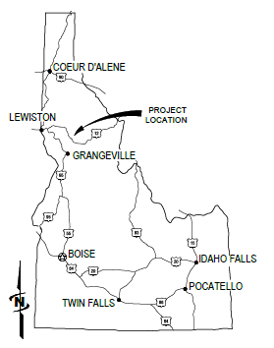

Project Location Maps
Sally Ann Creek Culvert #1, Clearwater, Idaho
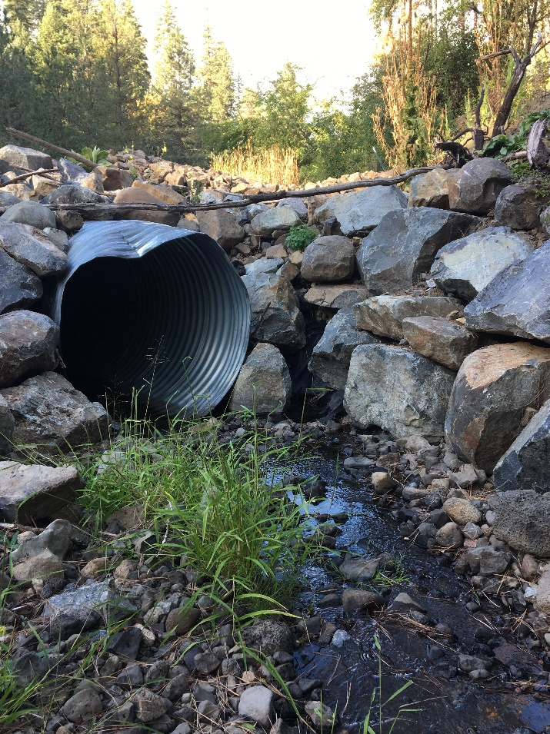

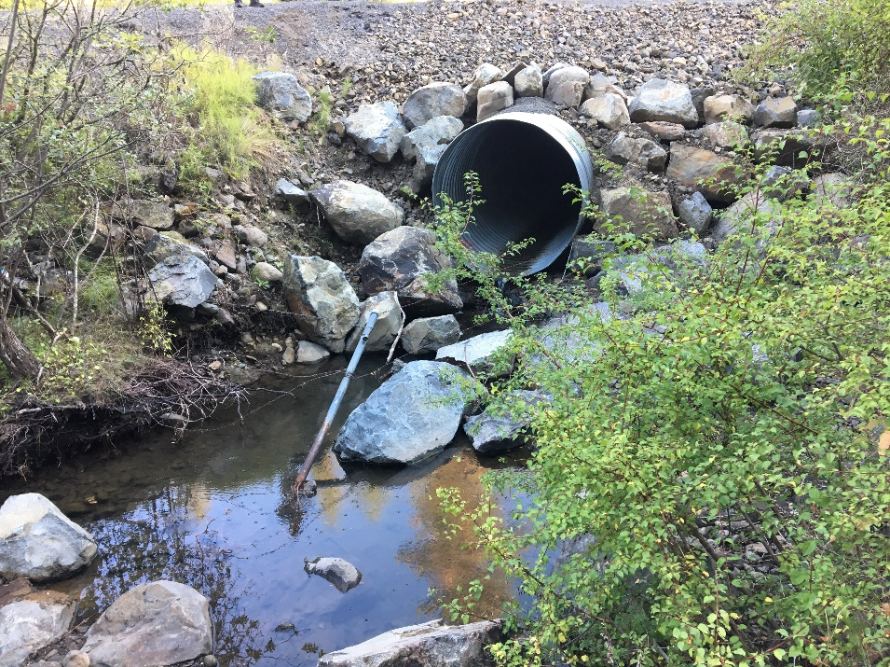

Sally Ann Creek Culvert #2, Clearwater, Idaho
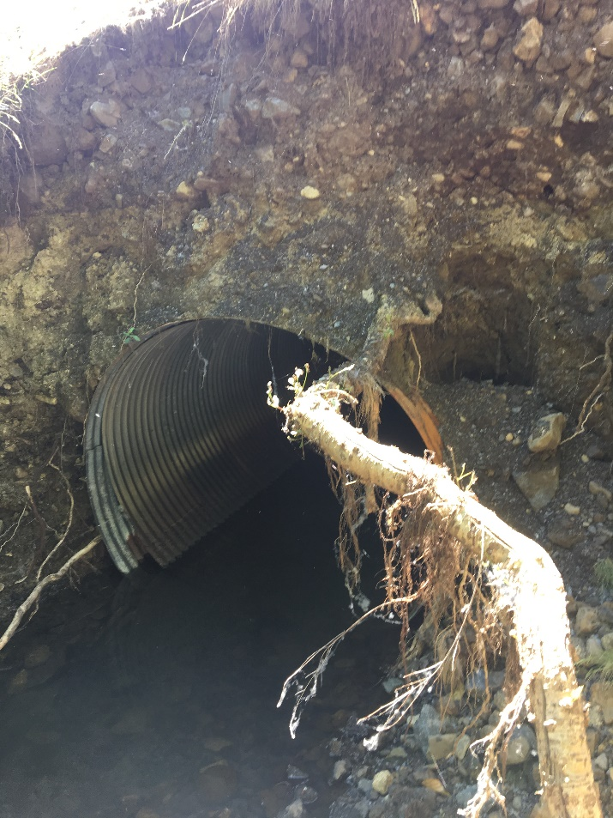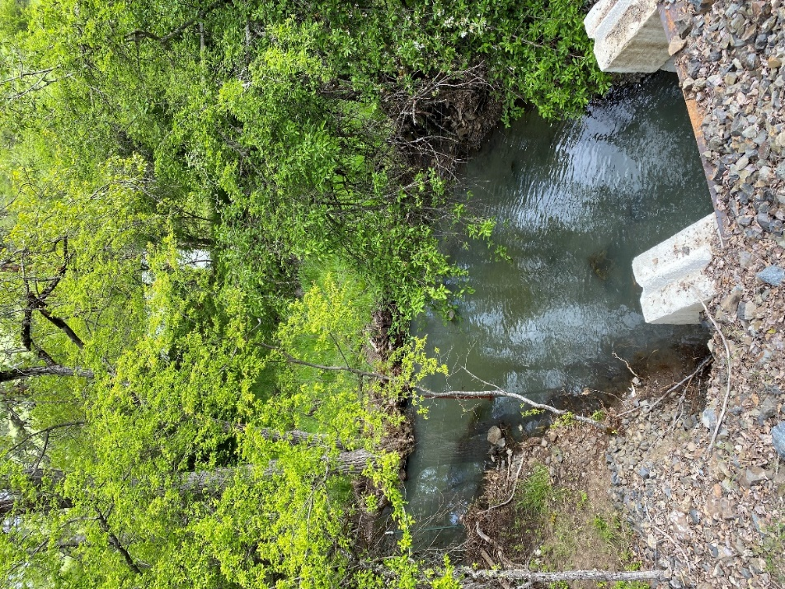

Sally Ann Creek Culvert #3, Clearwater, Idaho
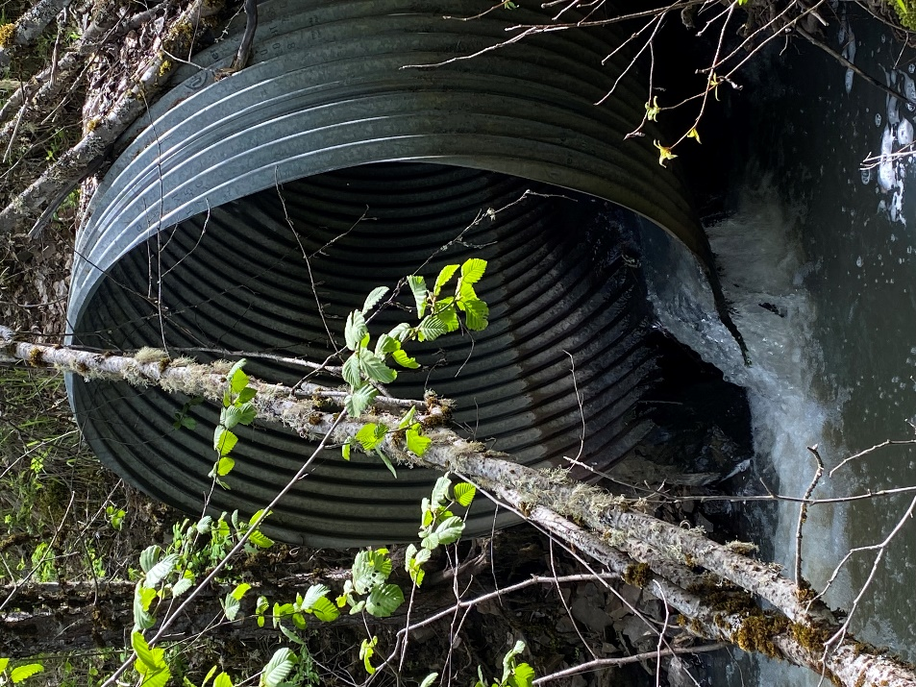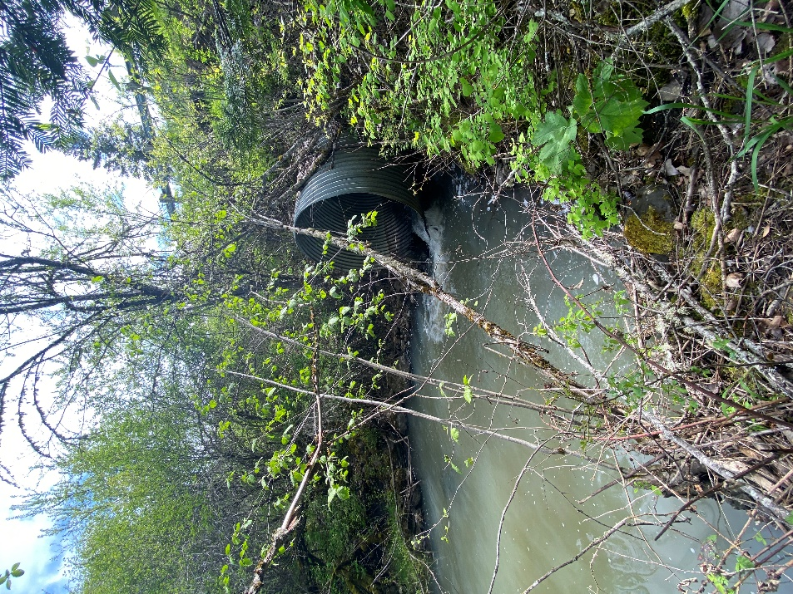

Wall Creek Bridge, Clearwater, Idaho
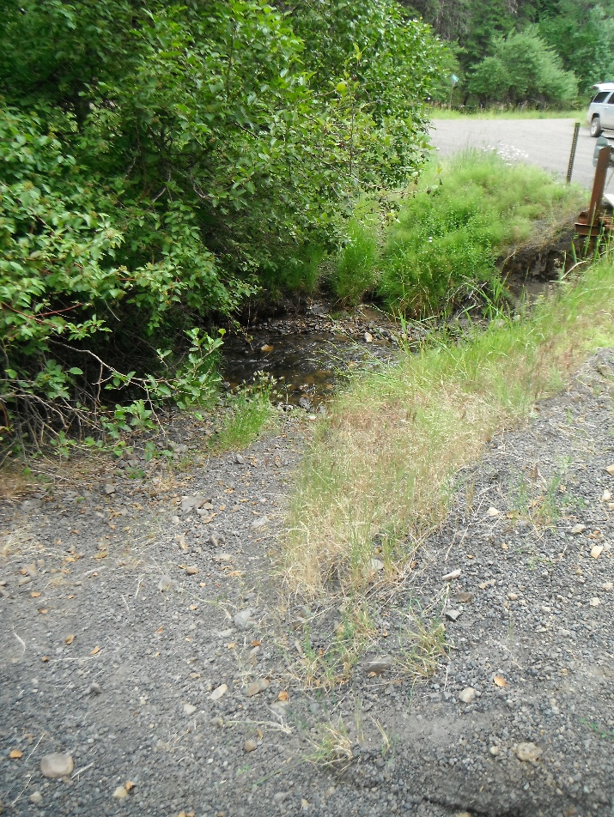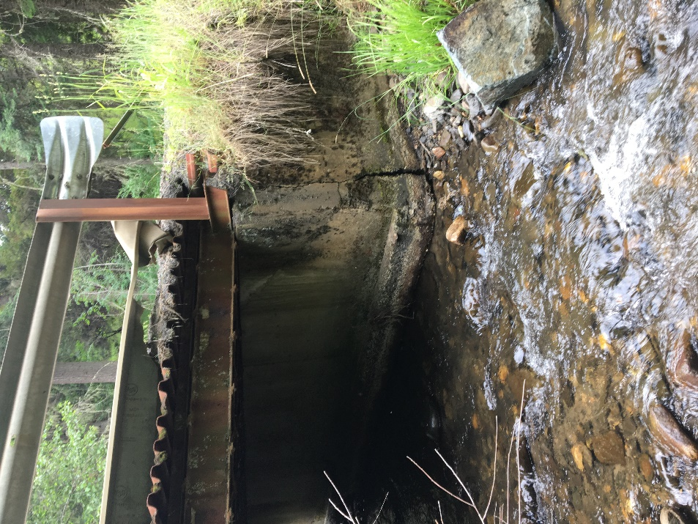

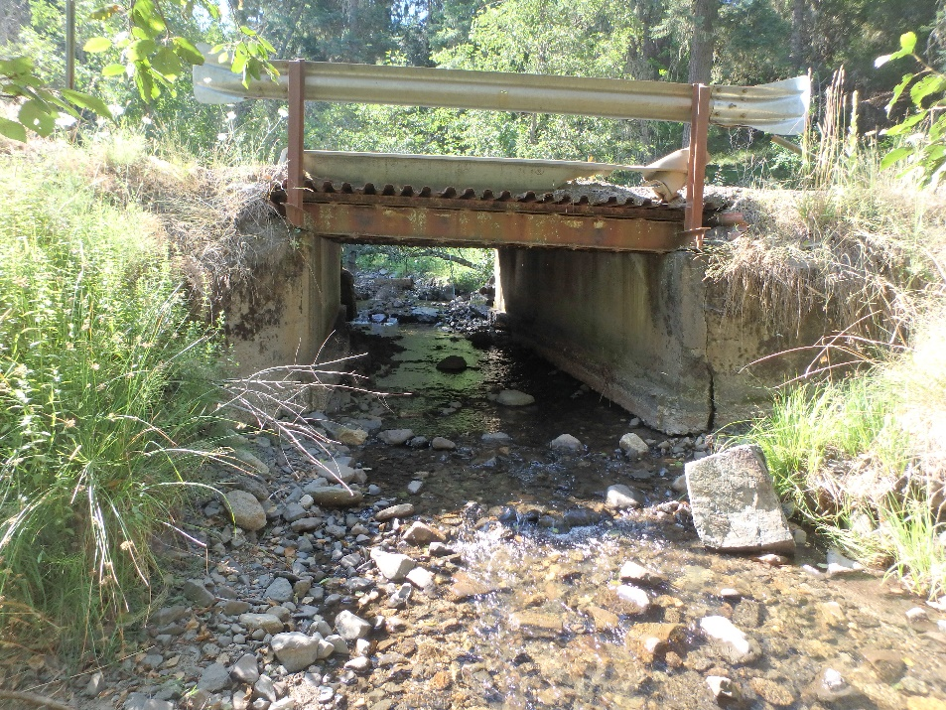
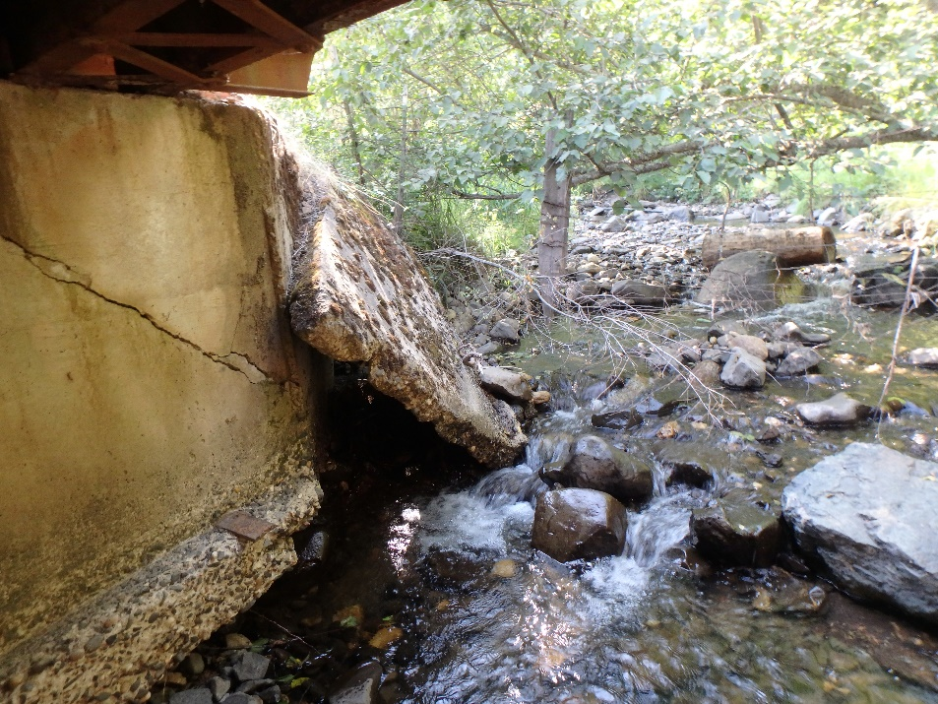

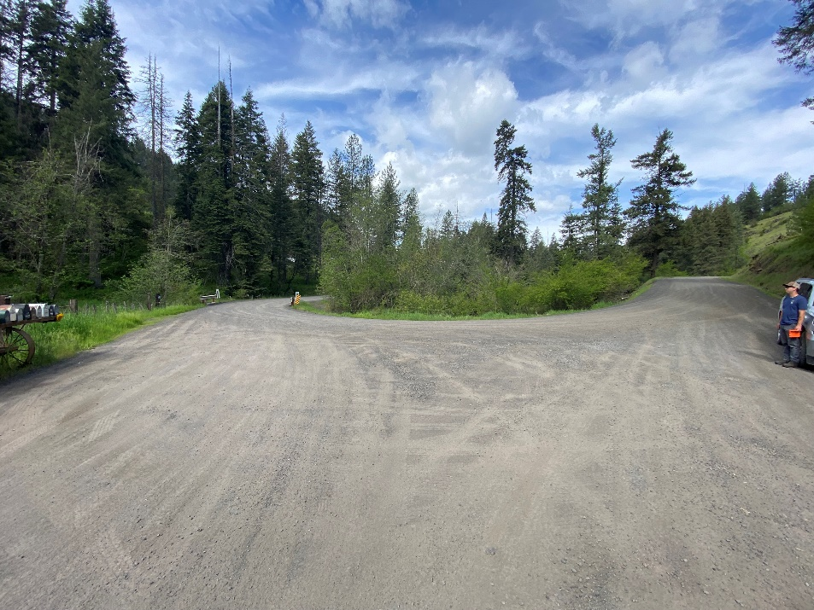

EXIBIT 4. Bonneville Power Administration Clauses

Bonneville Power Admistration Applicable Contract Clauses

This project is being funded partially through BPA funds secured by the Nez Perce Tribe. The Tribe is required by the BPA to apply the following contract clauses to all Tribal contracts / subcontracts. The word Government and Tribe shall be used interchangeably. The “Contractor” in these clauses refers to the Nez Perce Tribe. These clauses are incorporated into this solicitation/contract and must be complied with by the awarded construction firm.

EMPLOYMENT ELIGIBILITY VERIFICATION (10-18) (OCT 14) (BPI 10.1.8.3)

(a) “Employee assigned to the contract,” as used in this clause, means an employee who was hired after November 6, 1986, who is directly performing work, in the United States, under a contract that is required to include the clause as prescribed by 10.7.3. An employee is not considered to be directly performing work under a contract if the employee—

(1) Normally performs support work, such as indirect or overhead functions; and

(2) Does not perform any substantial duties applicable to the contract. (b) E-Verify enrollment and verification requirements.
(1) If the Contractor is not enrolled as a Federal Contractor in E-Verify at the time of the contract award, the
Contractor shall:

(A) Enroll. Enroll as a Federal Contractor in the E-Verify program within 30 calendar days of contract award;

(B) Verify all new employees. Within 90 calendar days of enrollment in the E-Verify program, begin to use E-Verify to initiate verification of employment eligibility of all new hires of the Contractor, who are working in the United States, whether or not assigned to the contract, within 3 business days after the date of hire (but see paragraph (a) (3) of this section); and

(C) Verify employees assigned to the contract. For each employee assigned to the contract, initiate verification within 90 calendar days after date of enrollment or within 30 calendar days of the employee’s assignment to the contract, whichever date is later (but see paragraph (a)(4) of this section).

(2) If the Contractor is enrolled as a Federal Contractor in E-Verify at time of contract award, the Contractor shall use E-Verify to initiate verification of employment eligibility of—

(A) All new employees.

(i) Enrolled 90 calendar days or more. The Contractor shall initiate verification of all new hires of the Contractor, who are working in the United States, whether or not assigned to the contract within 3 business days after the date of hire (but see paragraph (a)(3) of this section); or

(ii) Enrolled less than 90 calendar days. Within 90 calendar days after enrollment as a Federal Contractor in E-Verify, the Contractor shall initiate verification of all new hires of the Contractor, who are working in the United States, whether or not assigned to the contract, within 3 business days after the date of hire (but see paragraph)(3) of this section); or

(B) Employees assigned to the contract. For each employee assigned to the contract, the Contractor shall initiate verification within 90 calendar days after date of contract award or within 30 days after assignment to the contract, whichever date is later (but see paragraph (4) of this section).

(3) If the Contractor is an institution of higher education; a state or local government, or the government of a federally recognized Indian tribe; or a surety performing under a takeover agreement entered into with a federal agency pursuant to a performance bond, the Contractor may choose to verify only employees
assigned to the contract. The Contractor shall follow the applicable verification requirements at (a)(1) or (a)(2), respectively, except that any requirement for verification of new employees applies only to new employees assigned to the contract.

(4) Option to verify employment eligibility of all employees. The Contractor may elect to verify all existing employees hired after November 6, 1986, rather than just those employees assigned to the contract. The Contractor shall initiate verification for each existing employee working in the United States who was hired after November 6, 1986, within 180 calendar days of—

(A) Enrollment in the E-Verify program; or

(B) Notification to E-Verify Operations of the Contractor’s decision to exercise this option, using the contact information provided in the E-Verify program Memorandum of Understanding (MOU).

(5) The Contractor shall comply, for the period of performance of this contract, with the requirement of the E- Verify program MOU.

(A) The Department of Homeland Security (DHS) or the Social Security Administration (SSA) may terminate the Contractor’s MOU and deny access to the E-Verify system in accordance with the terms of the MOU. In such case, the Contractor will be referred to a Department of Energy suspension or debarment official.

(B) During the period between termination of the MOU and a decision by the suspension or debarment official whether to suspend or debar, the Contractor is excused from its obligations under paragraph (b) of this clause. If the suspension or debarment official determines not to suspend or debar the Contractor, then the Contractor must reenroll in E-Verify.

(c) Web site. Information on registration for and use of the E-Verify program can be obtained via the Internet at the Department of Homeland Security Web site: http://www.dhs.gov/E-Verify.

(d) Individuals previously verified. The Contractor is not required by this clause to perform additional employment verification using E-Verify for any employee—

(1) Whose employment eligibility was previously verified by the Contractor through the E-Verify program;

(2) Who has been granted and holds an active U.S. Government security clearance for access to confidential, secret, or top secret information in accordance with the National Industrial Security Program Operating Manual; or

(3) Who has undergone a completed background investigation and been issued credentials pursuant to Homeland Security Presidential Directive (HSPD) -12, Policy for a Common Identification Standard for Federal Employees and Contractors.

(e) Subcontracts. The contractor shall include the requirements of this clause, including this paragraph (d) (appropriately modified for identification of the parties), in each subcontract that—

(1) Is for:

(A) Services other than commercial services that are part of the purchase of a commercial-off-the-shelf
(COTS) item, performed by the COTS provider and are normally provided for that COTS item; (B) Construction.
(2) Has a value of more than $3,000; and

(3) Includes work performed in the United States.

SUBCONTRACTING WITH DEBARRED OR SUSPENDED ENTITIES (11-7) (JUL 13) (BPI 11.8.1; BPI 25.1.1)

(a) “Commercially available off-the-shelf (COTS) item,” as used in this clause means any item of supply (including construction material) that is:

(1) A commercial item (as defined in BPI 1.8);

(2) Sold in substantial quantities in the commercial marketplace; and

(3) Offered to the Government, under a contract or subcontract at any tier, without modification, in the same form in which it is sold in the commercial marketplace.

(b) The Government suspends or debars Contractors to protect the Government’s interests. Other than a subcontract for a commercially available off-the-shelf item, the Contractor shall not enter into any subcontract in excess of $30,000 with a Contractor that is debarred, suspended, by any executive agency unless there is a compelling reason to do so.

(c) The Contractor shall require each proposed subcontractor whose subcontract will exceed $30,000, other than a subcontractor providing a commercially available off-theshelf item, to disclose to the Contractor, in writing, whether as of the time of award of the subcontract, the subcontractor, or its principals, is or is not debarred, suspended by the Federal Government.

(d) The Contractor shall notify the Contracting Officer, in writing, before entering into a subcontract with a party (other than a subcontractor providing a commercially available off-the-shelf item) that is debarred, suspended (see www.sam.gov).

(e) Subcontracts. Unless this is a contract for the acquisition of commercial items, the Contractor shall include the requirements of this clause, including this paragraph (e) (appropriately modified for the identification of the parties), in each subcontract that exceed $30,000 in value and is not a subcontract for commercially available off-the-shelf items

CONTRACTOR SAFETY AND HEALTH (15-12) (APR 14) (BPI 15.2.4.1)

a) The Contractor shall furnish a place of employment that is free from recognized hazards that cause or have the potential to cause death or serious physical harm to employees; and shall comply with occupational safety and health standards promulgated under the Occupational Safety and Health Act of 1970 (Public Law 91-598). Contractor employees shall comply with occupational safety and health standards and all rules, regulations, and orders issued pursuant to this Act which are applicable to their own actions and conduct.

(1) All construction contractors working on contracts in excess of $100,000 shall comply with Department of Labor Contract Work Hours and Safety Standards (40 U.S.C. § 3701 et seq.). (2) The Contractor shall comply with
(i) National Fire Protection Association (NFPA) National Fire Codes for fire prevention and protection applicable to the work or facility being occupied or constructed;
(ii) NFPA 70E, Standard for Electrical Safety in the Workplace;
(iii) American Conference of Governmental Industrial Hygiene Threshold Limit Values for
Chemical Substances and Physical Agents and Biological Exposure Indices; and,
(iv) Any additional safety and health measures identified by the Contracting Officer.

This clause does not relieve the Contractor from complying with any additional specific or corporate safety and health requirements that it determines to be necessary to protect the safety and health of employees.

(b) The Contractor bears sole responsibility for ensuring that all contractor’s workers performing contract work possess the necessary knowledge and skills to perform the work correctly and safely. The Contractor shall make any training and certification records necessary to demonstrate compliance with this requirement available for review upon request by BPA.

(c) The Contractor shall hold BPA and any other owners of the site of work harmless from any and all suits, actions, and claims for injuries to or death of persons arising from any act or omission of the Contractor, its subcontractors, or any employee of the Contractor or subcontractors, in any way related to the work under this contract.

(d) The Contractor shall immediately notify the Contracting Officer (CO), the Contracting Officer’s Technical Representative (COTR), and the Safety Office by telephone at (360) 418-2397 of any death, injury, occupational disease or near miss arising from or incident to performance of work under this contract.
(1) The BPA Safety Office business hours are 7:00 AM to 4:00 PM Pacific Time. If the Safety Office Officials are not available to take the phone call the contractor shall leave a voicemail that includes the details of the event, and the Contractor’s contact information. The Contractor shall periodically repeat the phone call to the Safety Office until the Contractor is able to speak directly with a BPA Safety Official.
(2) The Contractor shall follow up each phone call notification with an email to SafetyNotification@BPA.gov immediately for any fatality or within 24 hours for non-fatal events.
(3) The Contractor shall complete BPA form 6410.15e Contractor’s Report of Personal Injury, Illness, or Property Damage Accident and submit the form to the CO, COTR, and Safety Office within five (5) working days of such an occurrence. The Contractor shall include photographs and witness statements with the report.
(4) In the case of a Near Miss Incident that does not involve injury, illness, or property damage, the Contractor
shall complete BPA Form 6410.18e Contractor’s Report of Incident/Near Miss and submit the form to the CO, COTR, and Safety Office within five (5) working days of such an occurrence. The Contractor shall include photographs and witness statements with the report.

(e) Notification of Imminent Danger and Workers Right to Decline Work
(1) All workers, including contractors and BPA employees, are responsible for identifying and notifying other workers in the affected area of imminent danger at the site of work. Imminent danger is any condition or practice that poses a danger that could reasonably be expected to cause death or severe physical hardship before the imminence of such danger could be eliminated through normal procedures.
(2) A contract worker has the right to ask, without reprisal, their onsite management and other workers to review safe work procedures and consider other alternatives before proceeding with a work procedure. Reprisal means any action taken against an employee in response to, or in revenge for, the employee having raised, in good faith, reasonable concerns about a safety and health aspect of the work required by the contract.
(3) A contract worker has the right to decline to perform tasks, without reprisal, that will endanger the safety and health of themself or of other workers.

(4) The Contractor shall establish procedures that allow workers to cease or decline work that may threaten the safety and health of the worker or other workers.

(f) BPA encourages all contractor workers to raise safety and health concerns as a way to identify and control safety hazards. The Contractor shall develop and communicate a formal procedure for submittal, resolution, and communication of resolution and corrective action to the worker submitting the concern. The procedure shall 1.) encourage workers to identify safety and health concerns directly to their supervisor and employer using the employer’s reporting process; and 2.) inform workers that they may raise safety concerns to BPA or the State OSHA. Workers may notify the Safety Office at (360) 418-2397 if the employer’s work process does not resolve the worker’s safety and health concern. BPA may coordinate the response to a contractor worker’s health and safety concerns with the State OSHA when necessary to facilitate resolution.

(g) BPA employees may direct the contractor to stop a work activity due to safety and health concerns. The BPA employee shall notify the Contractor orally with written confirmation, and request immediate initiation of corrective action. After receipt of the notice the Contractor shall immediately take corrective action to eliminate or mitigate the safety and health concern. When a BPA employee stops a work activity due to a safety and health concern the Contractor shall immediately notify the CO, provide a description of the event, and identify the BPA employee that halted the work activity. The Contractor shall not resume the stopped work activity until authorization to resume work is issued by a BPA Safety Official. The Contractor shall not be entitled to any equitable adjustment of the contract price or extension of the performance schedule when BPA stops a work activity due to safety and health concerns that occurred under the Contractor’s control.

(h) The Contractor shall keep a record of total monthly labor hours worked at the site of work. The Contractor shall include a separate calculation of the monthly total labor hours for each subcontractor in the contractor’s monthly data. Upon request by the CO, COTR or BPA Safety Office, the Contractor shall provide the total labor hours for a completed month to BPA no later than the 15th calendar day of the following month. The
requestor shall identify the required reporting format and procedures.

(i) The Contractor shall include this clause, including paragraph (i) in subcontracts. The Contractor may make appropriate changes in the designation of the parties to reflect the prime contractor--subcontractor arrangement. The Contractor is responsible for enforcing subcontractor compliance with this clause.

