Nez Perce Tribe
Reeducation of the Spalding Allen Collection

- Title: Spalding-Allen Collection – An Investigation of Continuity and Change in Nez Perce Country

- Grade Level: All Grades

- Length of Lesson: 45 minutes

- Essential Question: How have the items of the Spalding-Allen collection helped to preserve the material culture of the Nez Perce people?

- Student Learning Objectives:
The student will be able to:
- Understand how artifacts like those in the Spalding-Allen collection provide information about culture – past and present.
- Identify how culture change may be demonstrated through the introduction of new materials and technologies.
- Realize that, regardless of the passage of time, the need for functional clothing and transportation remains the same.

- Supplies/Materials:
        - Writing materials: Paper and pencils (each student)
        - Nez Perce Vocabulary Matching Exercise, p. 6 (one copy per student)
        - Nez Perce Vocabulary Matching Exercise Key, p. 7 (copy for teacher)
        - Drawing: Front of Shirt, p. 8 (one copy per student)
        - Teachers Answer Key – Activity 1, p. 9 (copy for teacher)
        - Teachers Answer Key – Activity 2, p. 10 (copy for teacher)
        - Spalding-Allen Collection Photographs found at Spalding-Allen Collection (Nez Perce) | Plateau Peoples' Web Portal (wsu.edu) (Print one copy of each of the ten pictures)

- National Education Standards
Standard 1: History
Students build an understanding of the cultural and social development of the United States, trace the role of migration and immigration of people in the development of the United States, and identify the sovereign status and role of American Indians in the development of the United States.

Goal 1.1: Build an understanding of the cultural and social development of the United States. Objective(s): Students will be able to:
- 4.SS.1.1.1 Identify characteristics of different cultural groups in Idaho.
- 4.SS.1.1.2 Describe ways that cultural groups have influenced and impacted each other.
- 4.SS.1.1.3 Explain the role of explorers and missionaries in the development of Idaho.

Goal 1.3: Identify the sovereign status and role of American Indians in the development of the United States. Objective(s): By the end of Grade 4, the student will be able to:
- 4.SS.1.3.6 Describe the preservation of American Indian resources, including cultural materials, history, language, and culture.

Standard 3: Economics
Students explain basic economic concepts, identify different influences on economic systems, and explain the concepts of personal finance.

Goal 3.1: Explain basic economic concepts. Objective(s): Students will be able to:
- 4.SS.3.1.1 Describe and analyze how American Indians and early settlers met their basic needs of food, shelter, and water.
- 4.SS.3.1.4 Identify goods and services in early Idaho settlements.

- Vocabulary:
Adorn – To put decorations or ornaments on a person or object that adds beauty and distinction.
Artifact – An object made by human work.
Characteristic – A distinguishing trait, feature, or quality.
Chronology – Arranging events, dates, etc. in their order of appearance.
Contact – The act of meeting and establishing communication with a person or group.
Contemporary – Living or happening in the same period of time.
Cultural Diffusion – Spread of one culture’s practices, beliefs, and/or items, like food, music, or tools.
Culture – The concepts, habits, skills, arts, instruments, institutions of a given people in a period of time.
Dye – A substance used to color fabric or hair.
Fringe – An ornamental border consisting of cords or threads that are either loose or are tied together and hang from the edges of garments.
Innovation – Something that is newly introduced; new method, custom; device; change in way of doing things.
Society – People living together in an ordered community.

- Background and Historical Context:
This collection includes some of the earliest physical surviving examples of Nez Perce culture. It honors the tradition, skill, and artisanship of the ancestors and guides the continuation of long-standing teachings and knowledge for all tribal members. Items in this collection represent important objects to men, women, and children throughout the living culture of the tribe, preserving tradition in various important moments in Nez Perce life then and now.

The story of the Spalding Allen Collection is a celebration of not only the tribal members that created these works of art, but the people who have cared for and handed them down for future generations. These pieces are a means for tribal members to remember and ensure the continuation of Nez Perce ways of life and plateau culture. As long as there are people to listen, each item will continue to have new stories to share as time changes how we relate to the past. Through this collection, we celebrate, honor, and continue to learn what the ancestors have to say and kept for their descendants.

Native cultures, like the Nez Perce, were not static and unchanging, they continued to evolve over time, adapting and adopting new ideas and technologies as they appeared. Objects, ideas, and behaviors were passed from one society to another. This mechanism is called cultural diffusion. Prior to the arrival of Euro-American influence, the most important object introduced to the Nez Perce was the horse. The arrival of the horse had a profound impact on the culture. Not only did it increase their mobility, allowing for more frequent travel east to the plains of Montana, but large horse herds became a source of wealth and prestige.

The first Europeans began exploring the northwest in the 1780s. Manufactured goods including metal objects and beads were already circulating through Nez Perce country when Lewis and Clark arrived in 1805. With the arrival of European trade goods, these materials were incorporated into existing practices, trade cloth replaced hide and so on.

For additional information, see the virtual exhibit at www.nps.gov/nepe and www.cr.nps.gov/museum/exhibits/nepe

- Lesson Procedures:
Activity 1: Transportation - approximately 20 minutes
Materials used for this activity:
- Pencils
- Nez Perce Vocabulary Matching Exercise, p. 6
- Nez Perce Vocabulary Matching Exercise – Key, p. 7
- Teachers Answer Key – Activity 1, p. 9
Pictures below are found at: Spalding-Allen Collection (Nez Perce) | Plateau Peoples' Web Portal (wsu.edu)
- Men’s Moccasin NEPE 8738-9
- Woman’s Saddle NEPE 8755
- Bone Quirt NEPE 8750
- Cradleboard NEPE 8787

Procedure: This first activity uses the photographs associated with transportation. Show students the photographs and ask these questions:
- What was the function and purpose for each item?
- Who would have used it?
- How was it made?
- What materials are used in its manufacturing?

Distribute vocabulary matching worksheet. Allow students to complete the worksheet, review it, and then ask the same questions again. Discuss the concept of cultural diffusion and ask students for examples. Did contact with Euro-Americans change the use or materials used?

Activity 2: Nimiipuu items from the 1800s – approximately 30 minutes

Materials used for this activity:
- Paper and pencil
- Drawing: Front of Shirt, p. 8
- Teachers Answer Key – Activity 2, p. 10
Pictures below are found at: Spalding-Allen Collection (Nez Perce) | Plateau Peoples' Web Portal (wsu.edu)
- Small Beaded bag w/ Belt NEPE 8753
- Women’s Hat NEPE 8745
- Deer Head Bag NEPE 8754
- Woman’s Dress NEPE 8758
- Cradleboard NEPE 33887
- Men’s Shirt NEPE 8760

Procedure: Divide students into groups of three to four then distribute one of the pictures to each group. Allow each group of students 5 to 10 minutes to examine the photograph and discuss what they see. Students should consider the following questions about culture and clothing and record the information on a sheet of paper.
- What is the item made from?
- What information does it give about the wearer?
- Can clothes show honor or respect to an individual or a group?

When each group is done, have the class compare the answers of each group, make corrections if necessary. Distribute the “Drawing: Front of Shirt” sheet to each student. Allow 5 to 10 minutes for students to identify five adornments they would use on a shirt, draw them on the shirt, and briefly explain their significance.

Conclusion: As one large group, discuss with the students how the items of the Spalding-Allen collection helped to preserve the material culture of the Nez Perce people.
- What kinds of cultural change can be seen in the items (introduction of new materials and technologies)?
- Have students compare the clothing they wore/brought to school with the items from the Spalding-Allen collection. What are some of the similarities and differences they see?

- Teacher Tips:
- Print pictures of objects identified in the activities for small groups of three to four students.
- Make copies of worksheets: “Vocabulary” and “Men’s Shirt Worksheet” (one per student).

- Evaluation/Assessment:
- Completed Nez Perce Vocabulary Exercise, p. 6
- Completed Drawing: Front of Shirt, p. 8

- Extension and Enrichment Activities:
- Using the park’s museum collection (www.nps.gov/museum/exhibits/nepe/index.html), do further research on people or artifacts mentioned in the selected activity.
- Visit a local museum, historical site, art gallery or historical society and report to the class on the experience.
- Invite a guest speaker from your area to provide additional information.
- Research a local group or artifact.

- Resources:
- Raymer, Dottie. Welcome to Kaya’s World 1764: Growing Up in a Native American Homeland.
- Middleton, Wisconsin: Pleasant Company Publications [American Girls Collection], 2003.
- Shawley, Stephen D. Nez Perce Dress: A Study in Culture Change. University of Idaho Anthropology Department, 1974.
- Nez Perce Tribe: www.nezperce.org
- Nez Perce National Historical Park: www.nps.gov/nepe
- Colville Confederated Tribes: http://www.colvilletribes.com/
- Umatilla Confederated Tribes: http://www.umatilla.nsn.us/

Nez Perce Vocabulary Matching Exercise
Directions: Match the words to their definitions using capital letters to indicate your choice.

____ 1. adorn | A. natural or synthetic coloring matter
____ 2. artifact | B. the introduction of something new
____ 3. characteristic | C. something created by humans usually for a practical purpose
____ 4. innovation | D. the set of shared attitudes, values, goals, and practices that characterizes a group
____ 5. chronology | E. to enhance the appearance of especially with beautiful objects
____ 6. contact | F. a condition in which two or more individuals or groups are placed in communication with each other
____ 7. contemporary | G. the science that deals with measuring time and assigns to events their proper place
____ 8. culture | H. an ornamental border of short lengths of straight or twisted thread, cord, or leather hanging from the edge of a garment
____ 9. fringe | - happening, existing, living, or coming into being during the same period of time
____10. dye | J. something that distinguishes or identifies a person or thing

Nez Perce Vocabulary Matching Exercise Key
Directions: Match the words to their definitions using capital letters to indicate your choice.

__E__ 1. adorn A. natural or synthetic coloring matter

__C__ 2. artifact B. the introduction of something new

__J__ 3. characteristic C. something created by humans usually for a practical purpose

__B__ 4. innovation D. the set of shared attitudes, values, goals, and practices that characterize a group.

__G__ 5. chronology E. to enhance the appearance of especially with beautiful objects

__F__ 6. contact F. a condition in which two or more individuals or groups are placed in communication with each other

__I__ 7. contemporary G. the science that deals with measuring time and assigns to events their proper place

__D__ 8. culture H. an ornamental border of short lengths of straight or twisted thread, cord, or leather hanging from the edge of a garment

__H__ 9. fringe I. to absorb into the culture or mores of a population or group

__A__ 10. dye J. something that distinguishes or identifies a person or thing

Drawing: Front of Shirt

Directions: Draw the various elements you see on the shirt and identify each item and its significance.

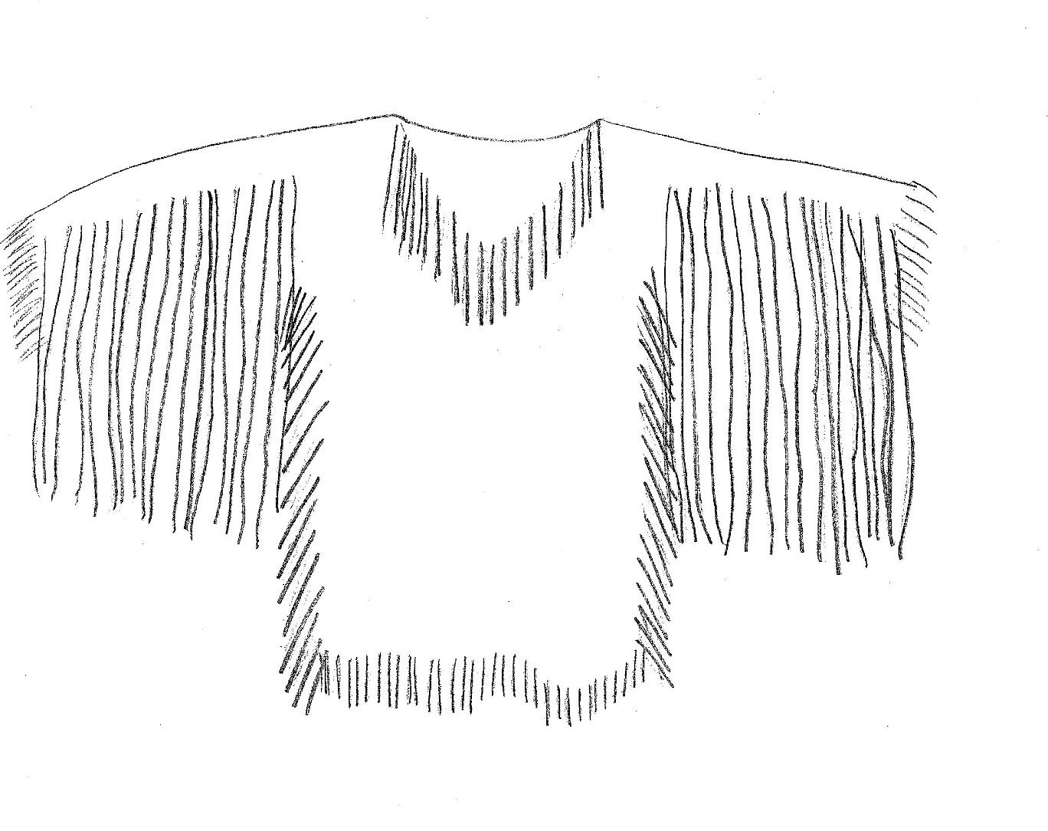

Items of Adornment and Explanation of Significance Chart

Items of Adornment Explanation of Significance

1) _____________________ __________________________________________________

2)________________________________________________________________________________

3)________________________________________________________________________________

4)________________________________________________________________________________

5)________________________________________________________________________________
Teachers Answer Key – Activity 1
The following four questions will be asked about the item in each picture that is passed out to the students.
- What was the function and purpose for each item?
- Who would have used it?
- How was it made?
- What materials are used in its manufacturing?
Here are the answers to the questions above for each item.
Men’s Moccasin –The moccasin protected the foot while traveling. Both men and women used moccasin’s, but in the 1800s only the men’s moccasin was decorated. The moccasin was made from the thicker hide of Moose, Elk or Buffalo and was decorated with items likes seed beads or porcupine quills. They were generally made by a mother or wife, but most men would know how to make or fix them while away on trips.
Woman’s Saddle – The saddle was used as a seat and provided the rider with support and control over the horse while riding. The tall back pommel serves as a back rest on long trips and the front pommel with its wide flat top makes sewing or beading possible while traveling.
Bone Quirt – The bone quirt was used to encourage a horse to move in a particular direction and speed. It was used by both men and women. The quirt is made from Elk bone with buckskin and rawhide straps. It is decorated with brass trade rings, brass tacks, and carvings.
Cradleboard – The cradleboard is used to carry a sleeping baby from birth to one year. It keeps a baby safe and protected and provides comfort. When wrapped up it the baby feels like it is being held. It would have been use by a mother. The cradleboard is made from soft deer skin and is decorated with black, white, and red seed beads and dentalia shells. The soft pillow is stuffed with deer hair.

Teachers Answer Key – Activity 2
The following three questions will be asked about the item in each picture that is passed out to the students.
- What is the item made from?
- What information does it give about the wearer?
- Can clothes show honor or respect to an individual or a group?
Here are the answers to the questions above for each item.
Small Beaded Bag with Belt – Made from deer hide buckskin, seed beads, rawhide, and tin cones. The man’s hip bag allows the owner to carry general items: fire kit, roots, pitch, etc. The bag is decorated with pink, green, yellow, and black beads as well as tin cones. The decorations show that the owner had access to trade and excess goods to make trade.

Woman’s Hat – The hat is made from handmade dogbane twine and dyed bear grass. These types of hats were presented to women that had achieved a certain status in the tribe as competent providers and leaders. They could not make their own hat; it must be earned. The hat is a symbol of status.

Deer Head Bag – The deer head bag is made from tanned deer hide to resemble a large deer head and embellished with seed beads. Used for storage.

Women’s Dress – The woman’s dress is made from two deer hides and is decorated with black, white, and red seed beads. It is adorned with brass thimbles and elk teeth, which can signify a good hunter in the family. (Only two of an elk’s teeth are made of ivory). The amount, variety, and size of the beads signifies that the owner had access to trade and excess materials to trade with others. It signifies that the individual was doing very well. Decorated clothing like this are not worn every day. They would only be worn for special occasions. (You would not want to clean fish in this dress).

Cradleboard – The cradleboard is made from soft deer skin and is decorated with black, white, and red seed beads and dentalia shells. The soft pillow is stuffed with deer hair. It is generally made by a grandmother or aunt to express love and protection for the child. Cradleboards are still in use by Nez Perce women today.

Men’s Shirt – The men’s shirt is made from elk hide and decorated with dyed porcupine quills and seed beads. Men’s shirts are decorated along the tops of arms, down the shoulders and back in two strips. Unlike women’s clothing that is decorated from arm to arm across the front and back. The wrapping of yellow quills on each buckskin fringe along with the exceptional quill work of the medallion on the chest are testament to a skilled quill worker. A shirt like this would likely be worn in the winter for ceremonies.

